Proiect SGBD

Platforma de E-Learning

Miclea Alexandru – Grupa 231

**1. Prezentați pe scurt baza de date (utilitatea ei)**

Modelul real al bazei de date este inspirat din platforme de E-Learning (Udemy, Coursera, etc.) disponibile pe internet. In acestea, studentii isi pot face un cont cu care sa cumpere acces la cursuri. Cursurile pot fi despre mai multe topicuri, precum programare, gatit, filozofie etc. Fiecare curs are mai multe capitole, fiecare capitol avand la randul lui teme si teste. Studentul poate sa adauge cursuri in wishlist, sa isi verifice progresul, sau sa adauge carduri de plata cu care va cumpara cursuri.

Utilitatea bazei de date este data de nevoia de a avea date referitoare la progresul unui student in cadrul cursurilor, de a le gestiona intr-un mod eficient si de a oferi posibilitatea acesarii intr-un mod facil a metricelor de interes pentru fiecare student. Totodata, pe baza acestor date, instructorii pot avea acces la date in timp real despre progresul studentilor lor.

**2. Realizați diagrama entitate-relație (ERD)**

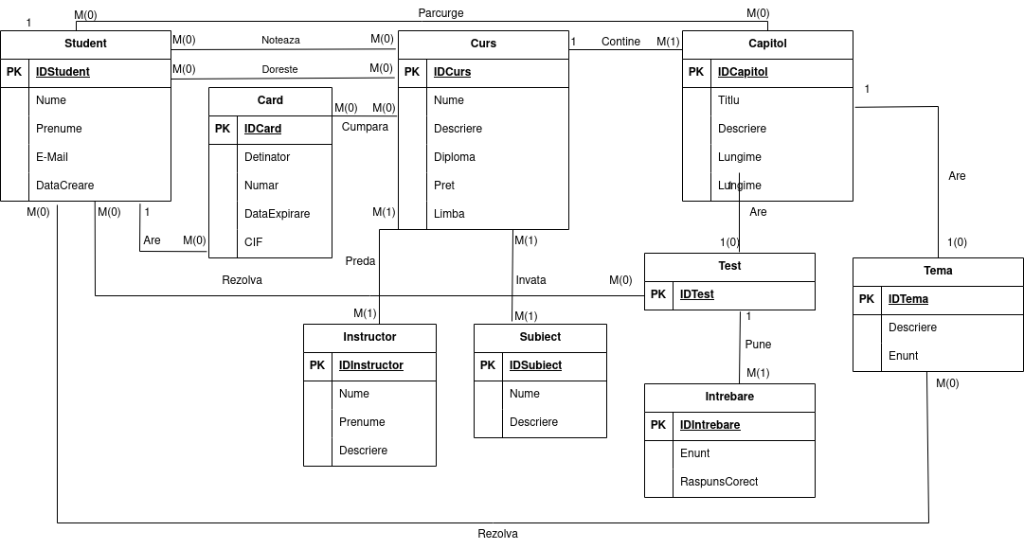

**3. Pornind de la diagrama entitate-relație, realizați diagrama conceptuală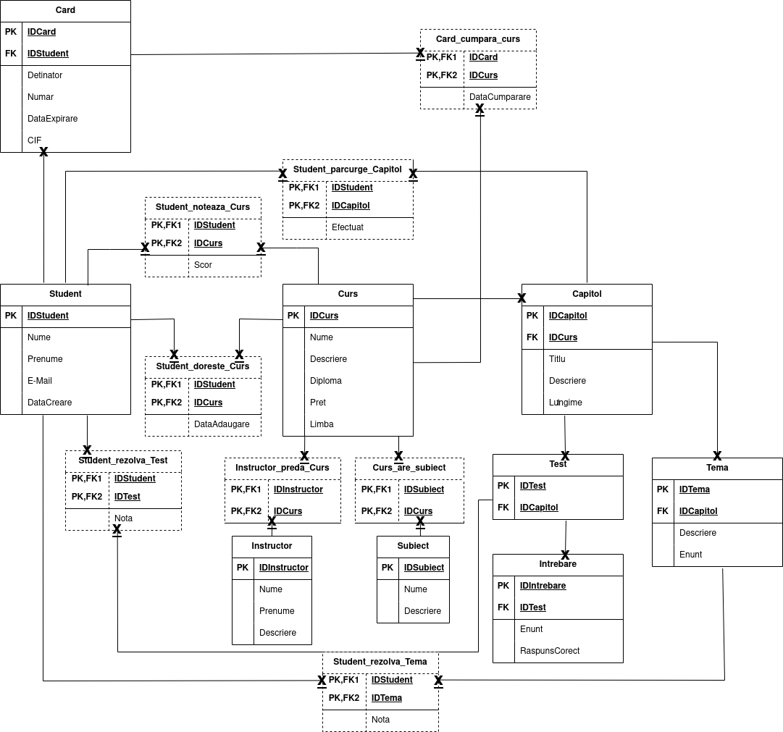 4.** I**mplementați în Oracle diagrama conceptuală realizată: definiți toate tabelele, definind toate constrângerile de integritate necesare (chei primare, cheile externe etc).**

create table Student (

idstudent int,

nume varchar2(40) constraint nn_nume_student not null,

prenume varchar2(40) constraint nn_prenume_student not null,

email varchar2(100) constraint nn_email_student not null,

datacreare date default to_date(sysdate, 'DD-MM-YYYY'),

constraint pk_student primary key(idstudent),

constraint uq_email_student unique(email)

);

create TABLE card (

idcard int,

idstudent int,

detinator varchar2(100) constraint nn_detinator_card not null,

numar number(16) constraint nn_numar_card not null,

dataexpirare date constraint nn_dataexpirare_card not null,

cif number(3) constraint nn_cif_card not null,

constraint pk_card primary key(idcard),

constraint fk_card_student foreign key(idstudent) references student(idstudent) on delete cascade,

constraint uq_numar_card unique(numar)

);

create table Curs (

idcurs int,

nume varchar2(100) constraint nn_nume_curs not null,

descriere varchar2(400),

diploma number default 0 constraint nn_diploma_curs not null,

pret number(5,2) constraint nn_pret_curs not null,

limba varchar2(20),

constraint pk_curs primary key(idcurs)

);

create table card_cumpara_curs (

idcard int,

idcurs int,

datacumparare date DEFAULT to_date(sysdate, 'DD-MM-YYYY'),

constraint pk_ccc primary key(idcard, idcurs),

constraint fk_ccc_card foreign key(idcard) references card(idcard) on delete cascade,

constraint fk_ccc_curs foreign key(idcurs) references curs(idcurs) on delete cascade

);

create table capitol (

idcapitol int,

idcurs int,

titlu varchar2(40) constraint nn_titlu_capitol not null,

descriere VARCHAR2(400),

lungime number(5,2) constraint nn_lungime_capitol not null,

constraint pk_capitol primary key(idcapitol),

constraint fk_capitol_curs foreign key(idcurs) references curs(idcurs) on delete cascade

);

create table test (

idtest int,

idcapitol int,

constraint pk_test primary key(idtest),

constraint fk_test_capitol foreign key(idcapitol) references capitol(idcapitol) on delete cascade

);

create table tema (

idtema int,

idcapitol int,

descriere VARCHAR2(400),

enunt VARCHAR2(400) constraint nn_enunt_tema not null,

constraint pk_tema primary key(idtema),

constraint fk_tema_capitol foreign key(idcapitol) references capitol(idcapitol) on delete cascade

);

create table subiect (

idsubiect int,

nume VARCHAR2(40) constraint nn_nume_subiect not null,

descriere VARCHAR2(400),

constraint pk_subiect primary key(idsubiect)

);

create table instructor (

idinstructor int,

nume varchar2(40) constraint nn_nume_instructor not null,

prenume varchar2(40) constraint nn_prenume_instructor not null,

descriere VARCHAR2(400),

constraint pk_instructor primary key(idinstructor)

);

create table intrebare (

idintrebare int,

idtest int,

enunt VARCHAR2(400) constraint nn_enunt_intrebare not null,

raspunscorect VARCHAR2(400) constraint nn_raspunscorect_tema not null,

constraint pk_intrebare primary key(idintrebare)

);

create table instructor_preda_curs (

idinstructor int,

idcurs int,

constraint pk_ipc primary key(idinstructor, idcurs),

constraint fk_ipc_instructor foreign key(idinstructor) references instructor(idinstructor) on delete cascade,

constraint fk_ipc_curs foreign key(idcurs) references curs(idcurs) on delete cascade

);

create table curs_are_subiect (

idcurs int,

idsubiect int,

constraint pk_cas primary key(idcurs, idsubiect),

constraint fk_cas_curs foreign key(idcurs) references curs(idcurs) on delete cascade,

constraint fk_cas_subiect foreign key(idsubiect) references subiect(idsubiect) on delete cascade

);

create table student_rezolva_tema (

idstudent int,

idtema int,

nota number(4,2),

constraint pk_srtema primary key(idstudent, idtema),

constraint fk_srtema_student foreign key(idstudent) references student(idstudent) on delete cascade,

constraint fk_srtema_tema foreign key(idtema) references tema(idtema) on delete cascade

);

create table student_rezolva_test (

idstudent int,

idtest int,

nota number(4,2),

constraint pk_srtest primary key(idstudent, idtest),

constraint fk_srtest_student foreign key(idstudent) references student(idstudent) on delete cascade,

constraint fk_srtest_test foreign key(idtest) references test(idtest) on delete cascade

);

create table student_doreste_curs (

idstudent int,

idcurs int,

dataadaugare date DEFAULT to_date(sysdate, 'DD-MM-YYYY'),

constraint pk_sdc primary key(idstudent, idcurs),

constraint fk_sdc_student foreign key(idstudent) references student(idstudent) on delete cascade,

constraint fk_sdc_curs foreign key(idcurs) references curs(idcurs) on delete cascade

);

create table student_noteaza_curs (

idstudent int,

idcurs int,

nota number(4,2),

constraint pk_snc primary key(idstudent, idcurs),

constraint fk_snc_student foreign key(idstudent) references student(idstudent) on delete cascade,

constraint fk_snc_curs foreign key(idcurs) references curs(idcurs) on delete cascade

);

create table student_parcurge_capitol (

idstudent int,

idcapitol int,

efectuat number default 0 constraint nn_efectuat_spc not null,

constraint pk_spc primary key(idstudent, idcapitol),

constraint fk_spc_student foreign key(idstudent) references student(idstudent) on delete cascade,

constraint fk_spc_capitol foreign key(idcapitol) references capitol(idcapitol) on delete cascade

);

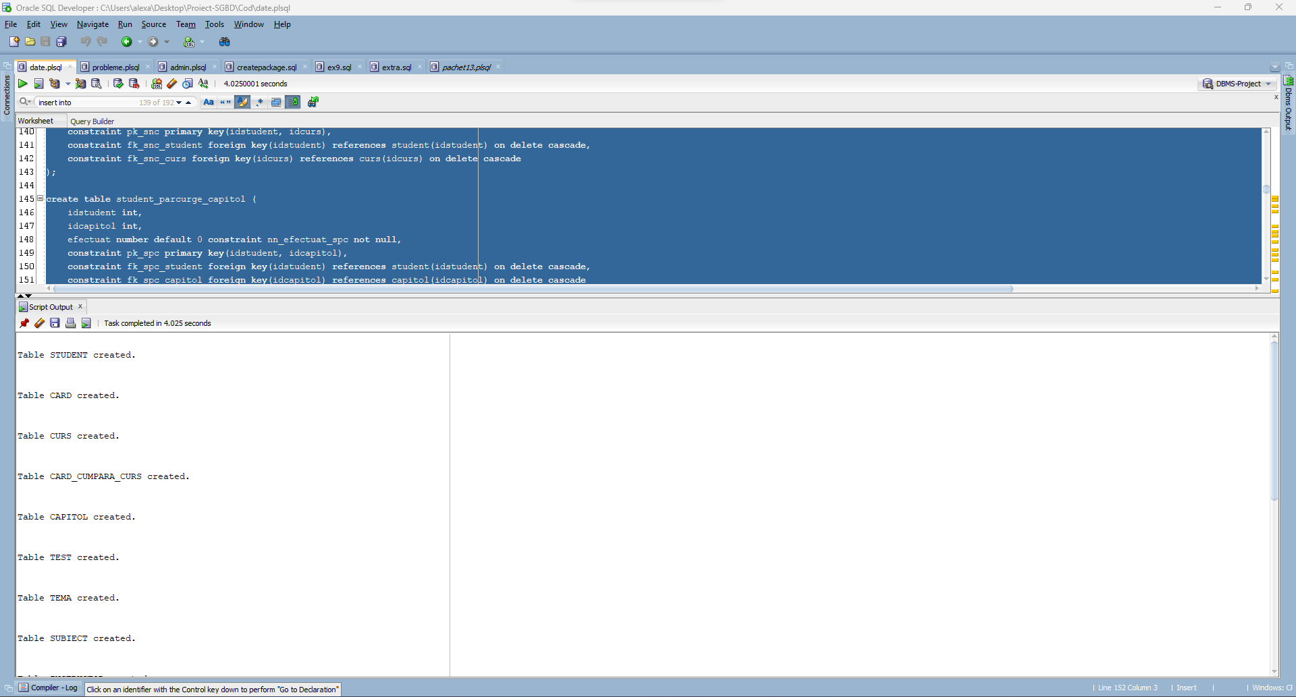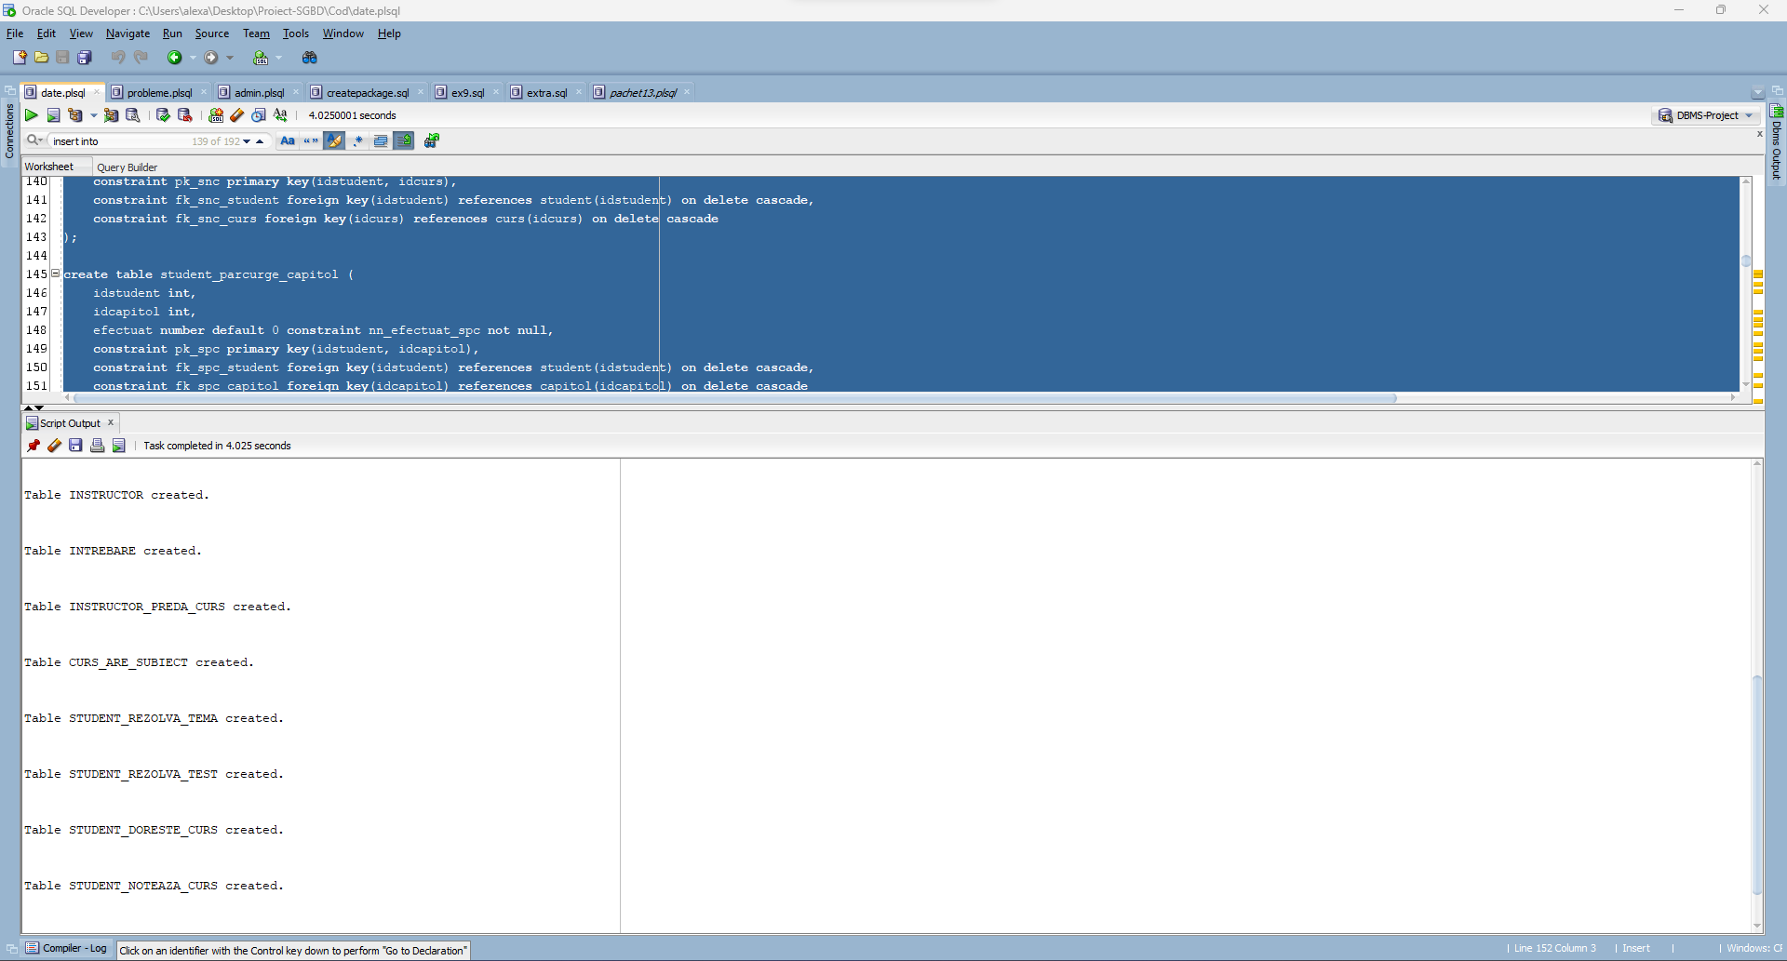

**5. Adăugați informații coerente în tabelele create (minim 5 înregistrări pentru fiecare entitate independentă; minim 10 înregistrări pentru tabela asociativă).**

create sequence seq_student start with 8 increment by 1;

insert into student (idstudent, nume, prenume, email, datacreare) values (1, 'Chirila', 'Alexandru Matei', 'chirilaalexandrumatei@outlook.com', sysdate - 30);

insert into student (idstudent, nume, prenume, email, datacreare) values (2, 'Costiniu', 'Gabriel', 'costiniugabriel@gmail.com', sysdate - 20);

insert into student (idstudent, nume, prenume, email, datacreare) values (3, 'Timandi', 'Karina', 'timandiliviaandreea@hotmail.com', sysdate - 150);

insert into student (idstudent, nume, prenume, email, datacreare) values (4, 'Stinga', 'Madalina', 'stingamadalina@gmail.com', sysdate - 10);

insert into student (idstudent, nume, prenume, email, datacreare) values (5, 'Balitiu', 'Teodora', 'balitiuteodora@outlook.com', sysdate - 360);

insert into student (idstudent, nume, prenume, email, datacreare) values (6, 'Stanasila', 'Ovidiu', 'stanasilaovidiu@protonmail.com', sysdate - 90);

insert into student (idstudent, nume, prenume, email, datacreare) values (7, 'Banica', 'Raul Cezar', 'banicaraulcezar@gmail.com', sysdate - 60);

select * from student;

create sequence seq_curs start with 6 increment by 1;

insert into curs (idcurs, nume, descriere, diploma, pret, limba) values (1, '100 days of code', 'Ia-o de la zero cu programarea in Python! Pe parcursul celor 100 de zile vei avea ceva de codat zilnic.', 1, 49.99, 'engleza');

insert into curs (idcurs, nume, descriere, diploma, pret, limba) values (2, 'Gateste cu Sylvester Stallone', 'Esentialul in gatit, astazi predat de catre nimeni altul decat Sylvester Stallone!', 0, 69.99, 'engleza');

insert into curs (idcurs, nume, descriere, diploma, pret, limba) values (3, 'Lectii de trompeta', 'Un instrument versatil, trompeta poate indulci orice coloana sonora.', 1, 39.99, 'romana');

insert into curs (idcurs, nume, descriere, diploma, pret, limba) values (4, 'Filozofie si etica academica', null, 0, 29.99, 'romana');

insert into curs (idcurs, nume, descriere, diploma, pret, limba) values (5, 'Chitara electrica 101', 'Totul despre chitara electrica. Invata sa canti rock, metal, whatever...', 1, 59.99, 'engleza');

select * from curs;

create sequence seq_card start with 11 increment by 1;

insert into card (idcard, idstudent, detinator, numar, dataexpirare, cif) values (1, 1, 'CHIRILA ALEXANDRU MATEI', 374245455400126, to_date('01/05/2026', 'DD/MM/YYYY'), 123);

insert into card (idcard, idstudent, detinator, numar, dataexpirare, cif) values (2, 2, 'COSTINIU GABRIEL', 378282246310005, to_date('01/05/2026', 'DD/MM/YYYY'), 423);

insert into card (idcard, idstudent, detinator, numar, dataexpirare, cif) values (3, 3, 'TIMANDI KARINA', 6250941006528599, to_date('01/06/2026', 'DD/MM/YYYY'), 434);

insert into card (idcard, idstudent, detinator, numar, dataexpirare, cif) values (4, 3, 'TIMANDI CRISTIAN', 6011000180331112, to_date('01/02/2026', 'DD/MM/YYYY'), 543);

insert into card (idcard, idstudent, detinator, numar, dataexpirare, cif) values (5, 4, 'STINGA MADALINA', 6011000991300009, to_date('01/12/2026', 'DD/MM/YYYY'), 564);

insert into card (idcard, idstudent, detinator, numar, dataexpirare, cif) values (6, 5, 'BALITIU TEODORA', 3566000020000410, to_date('01/02/2026', 'DD/MM/YYYY'), 954);

insert into card (idcard, idstudent, detinator, numar, dataexpirare, cif) values (7, 6, 'STANASILA ANDREEA', 3530111333300000, to_date('01/09/2026', 'DD/MM/YYYY'), 309);

insert into card (idcard, idstudent, detinator, numar, dataexpirare, cif) values (8, 6, 'STANASILA MARIAN', 5425233430109903, to_date('01/02/2026', 'DD/MM/YYYY'), 534);

insert into card (idcard, idstudent, detinator, numar, dataexpirare, cif) values (9, 7, 'BANICA RAUL CEZAR', 2222420000001113, to_date('01/03/2026', 'DD/MM/YYYY'), 890);

insert into card (idcard, idstudent, detinator, numar, dataexpirare, cif) values (10, 7, 'BANICA ADELINA', 5789432795823472, to_date('01/04/2026', 'DD/MM/YYYY'), 654);

select * from card;

insert into card_cumpara_curs (idcard, idcurs, datacumparare) values (1, 1, sysdate - 27);

insert into card_cumpara_curs (idcard, idcurs, datacumparare) values (1, 4, sysdate - 23);

insert into card_cumpara_curs (idcard, idcurs, datacumparare) values (2, 2, sysdate - 10);

insert into card_cumpara_curs (idcard, idcurs, datacumparare) values (3, 3, sysdate - 70);

insert into card_cumpara_curs (idcard, idcurs, datacumparare) values (4, 5, sysdate - 40);

insert into card_cumpara_curs (idcard, idcurs, datacumparare) values (6, 1, sysdate - 150);

insert into card_cumpara_curs (idcard, idcurs, datacumparare) values (6, 2, sysdate - 150);

insert into card_cumpara_curs (idcard, idcurs, datacumparare) values (7, 3, sysdate - 85);

insert into card_cumpara_curs (idcard, idcurs, datacumparare) values (8, 4, sysdate - 60);

insert into card_cumpara_curs (idcard, idcurs, datacumparare) values (9, 4, sysdate - 50);

insert into card_cumpara_curs (idcard, idcurs, datacumparare) values (10, 5, sysdate - 30);

select * from card_cumpara_curs;

create sequence seq_subiect start with 10 increment by 1;

insert into subiect (idsubiect, nume, descriere) values (1, 'Programare', null);

insert into subiect (idsubiect, nume, descriere) values (2, 'Python', null);

insert into subiect (idsubiect, nume, descriere) values (3, 'Gatit', null);

insert into subiect (idsubiect, nume, descriere) values (4, 'Instrumente', null);

insert into subiect (idsubiect, nume, descriere) values (5, 'Filozofie', null);

insert into subiect (idsubiect, nume, descriere) values (6, 'Academic', null);

insert into subiect (idsubiect, nume, descriere) values (7, 'Chitara', null);

insert into subiect (idsubiect, nume, descriere) values (8, 'Arama', null);

insert into subiect (idsubiect, nume, descriere) values (9, 'Actorie', null);

select * from subiect;

insert into curs_are_subiect (idcurs, idsubiect) values (1, 1);

insert into curs_are_subiect (idcurs, idsubiect) values (1, 2);

insert into curs_are_subiect (idcurs, idsubiect) values (2, 3);

insert into curs_are_subiect (idcurs, idsubiect) values (2, 9);

insert into curs_are_subiect (idcurs, idsubiect) values (3, 3);

insert into curs_are_subiect (idcurs, idsubiect) values (3, 8);

insert into curs_are_subiect (idcurs, idsubiect) values (4, 5);

insert into curs_are_subiect (idcurs, idsubiect) values (4, 6);

insert into curs_are_subiect (idcurs, idsubiect) values (5, 4);

insert into curs_are_subiect (idcurs, idsubiect) values (5, 7);

select * from curs_are_subiect;

create sequence seq_instructor start with 11 increment by 1;

insert into instructor (idinstructor, nume, prenume, descriere) values (1, 'Blidariu', 'Mihnea', 'Mihnea Blidariu (n. 6 septembrie 1979, Bacau, Romania) este un muzician roman, membru al formatiei rock Luna Amara, din Cluj-Napoca. Interpreteaza vocal, la trompeta si la chitara.');

insert into instructor (idinstructor, nume, prenume, descriere) values (2, 'Stallone', 'Sylvester', 'Sylvester Enzio Stallone (n. 6 iulie 1946, New York City, New York, SUA) este un actor, regizor si scenarist american.');

insert into instructor (idinstructor, nume, prenume, descriere) values (3, 'Yu', 'Angela', 'I am Angela, I am a developer with a passion for teaching. I am the lead instructor at the London App Brewery, a leading Programming Bootcamp.');

insert into instructor (idinstructor, nume, prenume, descriere) values (4, 'Stoenescu', 'Constantin', 'Prof. Dr.');

insert into instructor (idinstructor, nume, prenume, descriere) values (5, 'Brancoveanu', 'Romulus', 'Prof. Dr.');

insert into instructor (idinstructor, nume, prenume, descriere) values (6, 'Patrunsu', 'Dorina Mihaela', 'Prof. Dr.');

insert into instructor (idinstructor, nume, prenume, descriere) values (7, 'Cioaba', 'Catalin', 'Prof. Dr.');

insert into instructor (idinstructor, nume, prenume, descriere) values (8, 'Malan', 'David', null);

insert into instructor (idinstructor, nume, prenume, descriere) values (9, 'Botan', 'Andrei', null);

insert into instructor (idinstructor, nume, prenume, descriere) values (10, 'Fagadar', 'Nick', 'Nick Fagadar este un muzician roman, membru al formatiei rock Luna Amara, din Cluj-Napoca. Interpreteaza vocal si la chitara.');

select * from instructor;

insert into instructor_preda_curs (idinstructor, idcurs) values (3, 1);

insert into instructor_preda_curs (idinstructor, idcurs) values (8, 1);

insert into instructor_preda_curs (idinstructor, idcurs) values (2, 2);

insert into instructor_preda_curs (idinstructor, idcurs) values (1, 3);

insert into instructor_preda_curs (idinstructor, idcurs) values (4, 4);

insert into instructor_preda_curs (idinstructor, idcurs) values (5, 4);

insert into instructor_preda_curs (idinstructor, idcurs) values (6, 4);

insert into instructor_preda_curs (idinstructor, idcurs) values (7, 4);

insert into instructor_preda_curs (idinstructor, idcurs) values (9, 5);

insert into instructor_preda_curs (idinstructor, idcurs) values (10, 5);

select * from instructor_preda_curs;

create sequence seq_capitol start with 8 increment by 1;

insert into capitol (idcapitol, idcurs, titlu, descriere, lungime) values (1, 1, 'Python introduction', null, 109.35);

insert into capitol (idcapitol, idcurs, titlu, descriere, lungime) values (2, 1, 'Daily assignments', null, 65.21);

insert into capitol (idcapitol, idcurs, titlu, descriere, lungime) values (3, 2, 'Salads with Adrian Balboa', null, 36.56);

insert into capitol (idcapitol, idcurs, titlu, descriere, lungime) values (4, 2, 'Steak. Meats.', null, 36.56);

insert into capitol (idcapitol, idcurs, titlu, descriere, lungime) values (5, 3, 'Ritmuri de hora in Sol Major', null, 20.15);

insert into capitol (idcapitol, idcurs, titlu, descriere, lungime) values (6, 4, 'Filozofia in Inteligenta Artificiala', null, 300.15);

insert into capitol (idcapitol, idcurs, titlu, descriere, lungime) values (7, 5, 'Stilul Grunge', null, 60.25);

select * from capitol;

create sequence seq_test start with 12 increment by 1;

insert into test (idtest, idcapitol) values (1, 1);

insert into test (idtest, idcapitol) values (2, 1);

insert into test (idtest, idcapitol) values (3, 1);

insert into test (idtest, idcapitol) values (4, 3);

insert into test (idtest, idcapitol) values (5, 4);

insert into test (idtest, idcapitol) values (6, 5);

insert into test (idtest, idcapitol) values (7, 6);

insert into test (idtest, idcapitol) values (8, 6);

insert into test (idtest, idcapitol) values (9, 6);

insert into test (idtest, idcapitol) values (10, 6);

insert into test (idtest, idcapitol) values (11, 7);

select * from test;

create sequence seq_intrebare start with 23 increment by 1;

insert into intrebare (idintrebare, idtest, enunt, raspunscorect) values (1, 1, 'What is a list?', 'Data collection');

insert into intrebare (idintrebare, idtest, enunt, raspunscorect) values (2, 1, 'What does print() do?', 'Prints contents to the STDOUT');

insert into intrebare (idintrebare, idtest, enunt, raspunscorect) values (3, 2, 'What is the difference between a list and a tuple?', 'Tuples are immutable, lists are not');

insert into intrebare (idintrebare, idtest, enunt, raspunscorect) values (4, 2, 'How to reverse a list using slices?', 'list = list[::-1]');

insert into intrebare (idintrebare, idtest, enunt, raspunscorect) values (5, 3, 'Is backtracking efficient?', 'No.');

insert into intrebare (idintrebare, idtest, enunt, raspunscorect) values (6, 3, 'What is the most optimal sorting complexity?' , 'O(n)');

insert into intrebare (idintrebare, idtest, enunt, raspunscorect) values (7, 4, 'Ceaser salad. Dressing?', 'Light dressing.');

insert into intrebare (idintrebare, idtest, enunt, raspunscorect) values (8, 4, 'Should you add red fruits to salad?', 'Yes (but only a couple slices).');

insert into intrebare (idintrebare, idtest, enunt, raspunscorect) values (9, 5, 'Should you cook steak beyond medium-rare?', 'Yes, but only certain cuts.');

insert into intrebare (idintrebare, idtest, enunt, raspunscorect) values (10, 5, 'Does lamb go well with wine?', 'The greeks have been doing it for centuries so of course yes.');

insert into intrebare (idintrebare, idtest, enunt, raspunscorect) values (11, 6, 'Ce hora este cea mai populara in Romania?', 'Hora Unirii.');

insert into intrebare (idintrebare, idtest, enunt, raspunscorect) values (13, 7, 'Are viata sfarsit?', 'In conceptia religiei, nu.');

insert into intrebare (idintrebare, idtest, enunt, raspunscorect) values (15, 8, 'Ce este moralitatea?', 'Depinde pe cine intrebi.');

insert into intrebare (idintrebare, idtest, enunt, raspunscorect) values (17, 9, 'Este inteligenta artificiala un domeniu ce reprezinta interes academic?', 'Da.');

insert into intrebare (idintrebare, idtest, enunt, raspunscorect) values (19, 10, 'Reprezinta inteligenta arificiala nesupervizata un pericol?', 'Nu (se cer detalii).');

insert into intrebare (idintrebare, idtest, enunt, raspunscorect) values (21, 11, 'Care a fost prima trupa considerata Grunge?', 'Green River');

insert into intrebare (idintrebare, idtest, enunt, raspunscorect) values (22, 11, 'Care a fost cea mai populara trupa Grunge?', 'Nirvana');

select * from intrebare;

create sequence seq_tema start with 9 increment by 1;

insert into tema (idtema, idcapitol, descriere, enunt) values (1, 1, null, 'Create a Python script that implements as many concepts as possible.');

insert into tema (idtema, idcapitol, descriere, enunt) values (2, 2, null, 'Day 20: Nth Fibonacci number');

insert into tema (idtema, idcapitol, descriere, enunt) values (3, 2, null, 'Day 40: First 100 prime numbers');

insert into tema (idtema, idcapitol, descriere, enunt) values (4, 2, null, 'Day 60: Cash register');

insert into tema (idtema, idcapitol, descriere, enunt) values (5, 2, null, 'Day 80: Bank administration');

insert into tema (idtema, idcapitol, descriere, enunt) values (6, 2, null, 'Day 100: print("I did it!");');

insert into tema (idtema, idcapitol, descriere, enunt) values (7, 5, null, 'Filmeaza ritmul tau');

insert into tema (idtema, idcapitol, descriere, enunt) values (8, 7, null, 'Canta o melodie preferata din stilul grunge');

select * from tema;

insert into student_noteaza_curs (idstudent, idcurs) values (1, 1);

insert into student_noteaza_curs (idstudent, idcurs) values (2, 2);

insert into student_noteaza_curs (idstudent, idcurs) values (3, 3);

insert into student_noteaza_curs (idstudent, idcurs) values (5, 1);

insert into student_noteaza_curs (idstudent, idcurs) values (6, 3);

insert into student_noteaza_curs (idstudent, idcurs) values (7, 4);

insert into student_noteaza_curs (idstudent, idcurs, nota) values (1, 4, 8.00);

insert into student_noteaza_curs (idstudent, idcurs, nota) values (3, 5, 9.00);

insert into student_noteaza_curs (idstudent, idcurs, nota) values (5, 2, 10.00);

insert into student_noteaza_curs (idstudent, idcurs, nota) values (6, 4, 7.50);

insert into student_noteaza_curs (idstudent, idcurs, nota) values (7, 5, 3.00);

select * from student_noteaza_curs;

insert into student_doreste_curs (idstudent, idcurs) values (4, 1);

insert into student_doreste_curs (idstudent, idcurs) values (4, 2);

insert into student_doreste_curs (idstudent, idcurs) values (4, 3);

insert into student_doreste_curs (idstudent, idcurs) values (1, 3);

insert into student_doreste_curs (idstudent, idcurs) values (3, 4);

insert into student_doreste_curs (idstudent, idcurs) values (5, 5);

insert into student_doreste_curs (idstudent, idcurs) values (6, 1);

insert into student_doreste_curs (idstudent, idcurs) values (6, 2);

insert into student_doreste_curs (idstudent, idcurs) values (7, 1);

insert into student_doreste_curs (idstudent, idcurs) values (7, 2);

select * from student_doreste_curs;

insert into student_parcurge_capitol (idstudent, idcapitol, efectuat) values (1, 1, 1);

insert into student_parcurge_capitol (idstudent, idcapitol, efectuat) values (1, 2, 0);

insert into student_parcurge_capitol (idstudent, idcapitol, efectuat) values (1, 6, 0);

insert into student_parcurge_capitol (idstudent, idcapitol, efectuat) values (2, 3, 1);

insert into student_parcurge_capitol (idstudent, idcapitol, efectuat) values (2, 4, 0);

insert into student_parcurge_capitol (idstudent, idcapitol, efectuat) values (3, 5, 0);

insert into student_parcurge_capitol (idstudent, idcapitol, efectuat) values (3, 7, 0);

insert into student_parcurge_capitol (idstudent, idcapitol, efectuat) values (5, 1, 1);

insert into student_parcurge_capitol (idstudent, idcapitol, efectuat) values (5, 2, 1);

insert into student_parcurge_capitol (idstudent, idcapitol, efectuat) values (5, 3, 1);

insert into student_parcurge_capitol (idstudent, idcapitol, efectuat) values (5, 4, 0);

insert into student_parcurge_capitol (idstudent, idcapitol, efectuat) values (6, 5, 1);

insert into student_parcurge_capitol (idstudent, idcapitol, efectuat) values (6, 6, 0);

insert into student_parcurge_capitol (idstudent, idcapitol, efectuat) values (7, 6, 1);

insert into student_parcurge_capitol (idstudent, idcapitol, efectuat) values (7, 7, 1);

select * from student_parcurge_capitol;

insert into student_rezolva_tema (idstudent, idtema, nota) values (1, 1, 10.00);

insert into student_rezolva_tema (idstudent, idtema, nota) values (1, 2, 10.00);

insert into student_rezolva_tema (idstudent, idtema, nota) values (1, 3, 10.00);

insert into student_rezolva_tema (idstudent, idtema) values (1, 4);

insert into student_rezolva_tema (idstudent, idtema) values (1, 5);

insert into student_rezolva_tema (idstudent, idtema) values (1, 6);

insert into student_rezolva_tema (idstudent, idtema) values (3, 7);

insert into student_rezolva_tema (idstudent, idtema) values (3, 8);

insert into student_rezolva_tema (idstudent, idtema, nota) values (5, 1, 10.00);

insert into student_rezolva_tema (idstudent, idtema, nota) values (5, 2, 10.00);

insert into student_rezolva_tema (idstudent, idtema, nota) values (5, 3, 10.00);

insert into student_rezolva_tema (idstudent, idtema, nota) values (5, 4, 10.00);

insert into student_rezolva_tema (idstudent, idtema, nota) values (5, 5, 10.00);

insert into student_rezolva_tema (idstudent, idtema, nota) values (5, 6, 10.00);

insert into student_rezolva_tema (idstudent, idtema, nota) values (6, 5, 9.00);

insert into student_rezolva_tema (idstudent, idtema, nota) values (7, 8, 8.00);

select * from student_rezolva_tema;

insert into student_rezolva_test (idstudent, idtest, nota) values (1, 1, 10.00);

insert into student_rezolva_test (idstudent, idtest, nota) values (1, 2, 9.00);

insert into student_rezolva_test (idstudent, idtest, nota) values (1, 3, 10.00);

insert into student_rezolva_test (idstudent, idtest, nota) values (1, 7, 7.00);

insert into student_rezolva_test (idstudent, idtest) values (1, 8);

insert into student_rezolva_test (idstudent, idtest) values (1, 9);

insert into student_rezolva_test (idstudent, idtest) values (1, 10);

insert into student_rezolva_test (idstudent, idtest) values (2, 4);

insert into student_rezolva_test (idstudent, idtest) values (3, 6);

insert into student_rezolva_test (idstudent, idtest) values (3, 11);

insert into student_rezolva_test (idstudent, idtest, nota) values (5, 1, 10.00);

insert into student_rezolva_test (idstudent, idtest, nota) values (5, 2, 10.00);

insert into student_rezolva_test (idstudent, idtest, nota) values (5, 3, 10.00);

insert into student_rezolva_test (idstudent, idtest, nota) values (5, 4, 10.00);

insert into student_rezolva_test (idstudent, idtest) values (5, 5);

insert into student_rezolva_test (idstudent, idtest, nota) values (6, 6, 10.00);

insert into student_rezolva_test (idstudent, idtest, nota) values (6, 7, 6.00);

insert into student_rezolva_test (idstudent, idtest) values (6, 8);

insert into student_rezolva_test (idstudent, idtest) values (6, 9);

insert into student_rezolva_test (idstudent, idtest) values (6, 10);

insert into student_rezolva_test (idstudent, idtest, nota) values (7, 7, 9.00);

insert into student_rezolva_test (idstudent, idtest, nota) values (7, 8, 8.50);

insert into student_rezolva_test (idstudent, idtest, nota) values (7, 9, 9.40);

insert into student_rezolva_test (idstudent, idtest, nota) values (7, 10, 10.00);

insert into student_rezolva_test (idstudent, idtest, nota) values (7, 11, 10.00);

select * from student_rezolva_test;

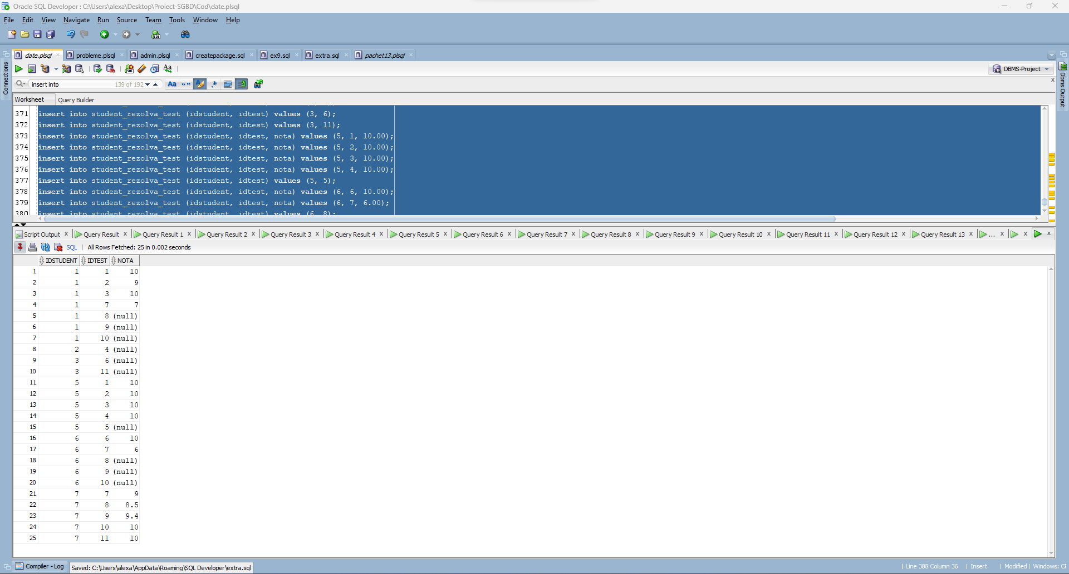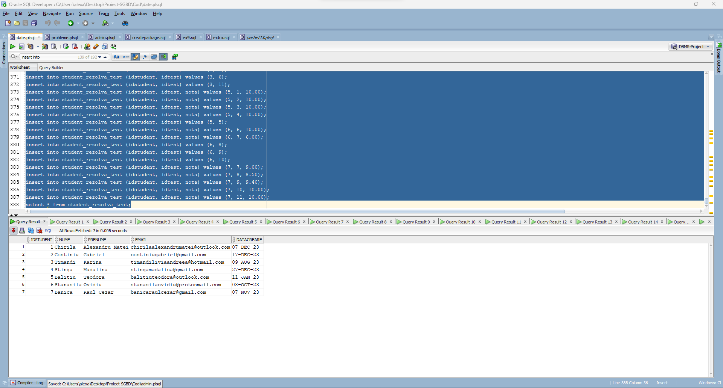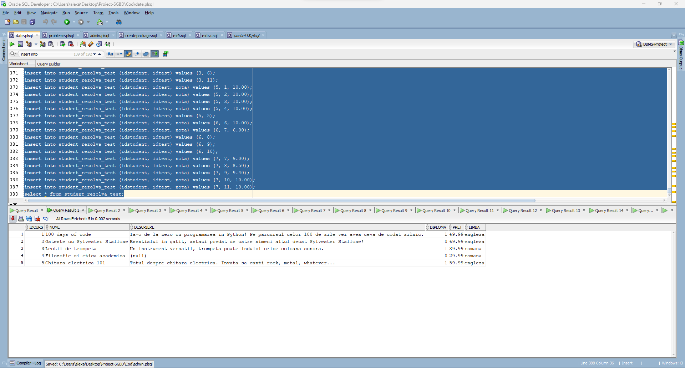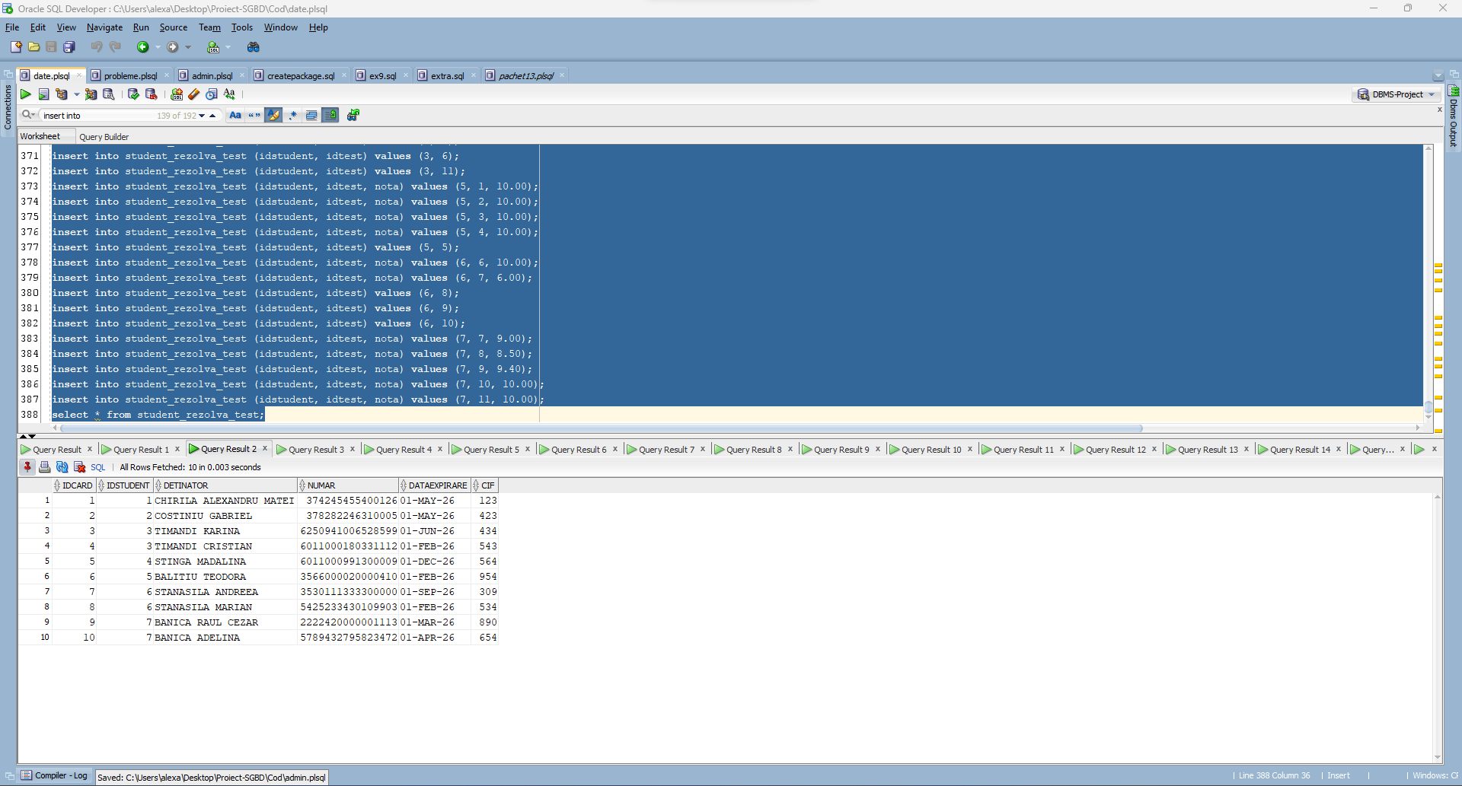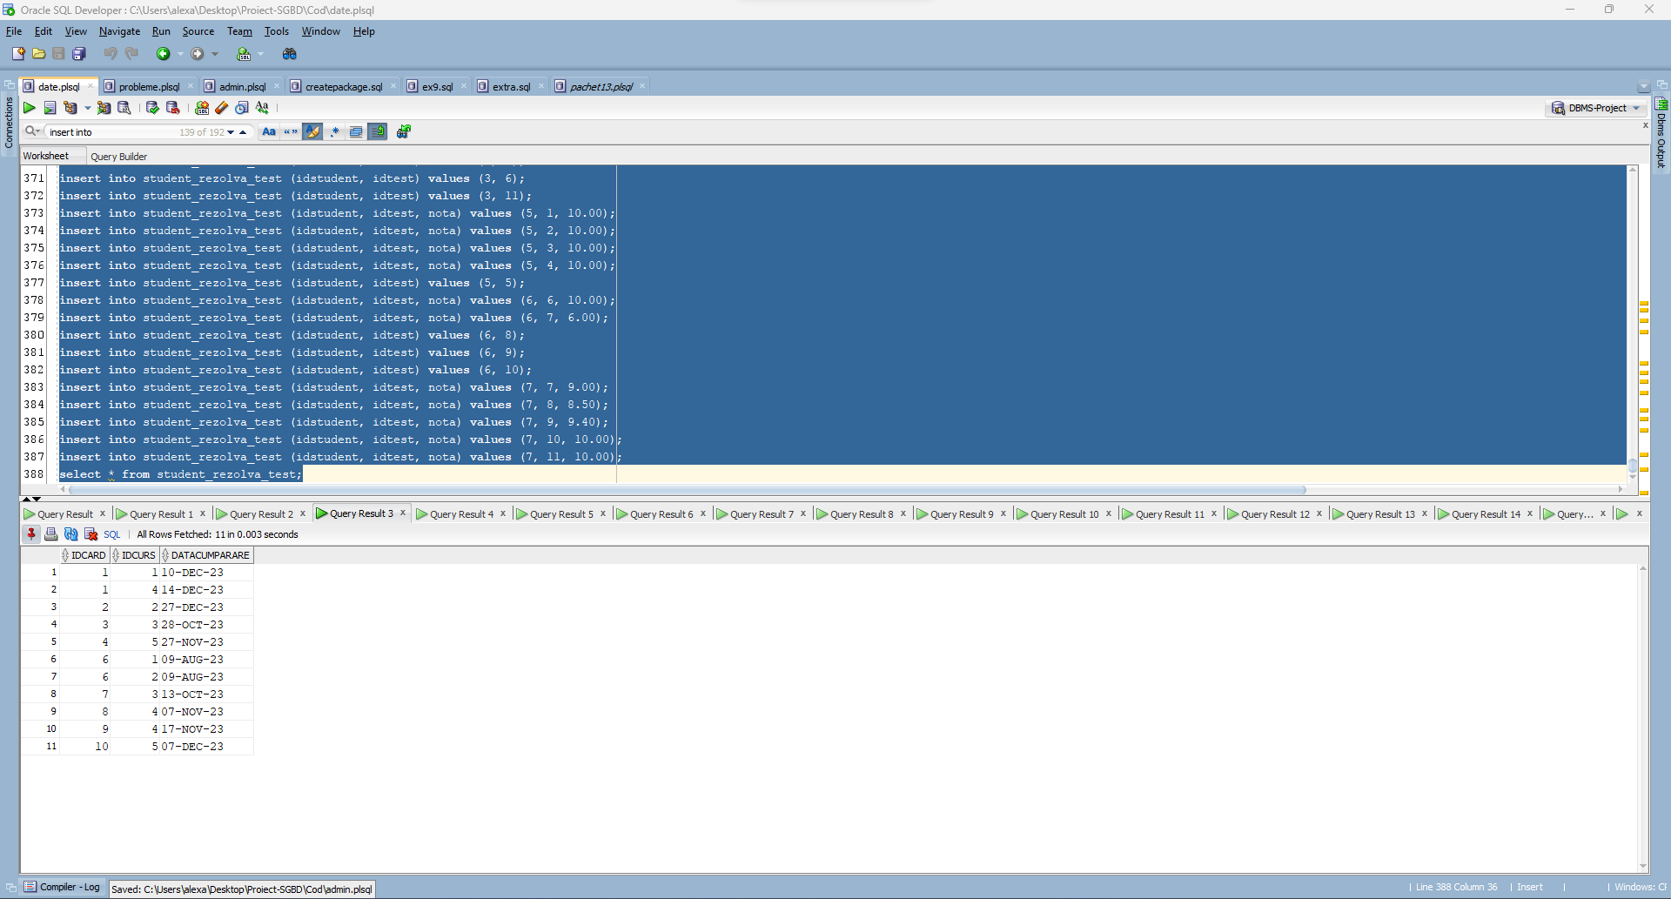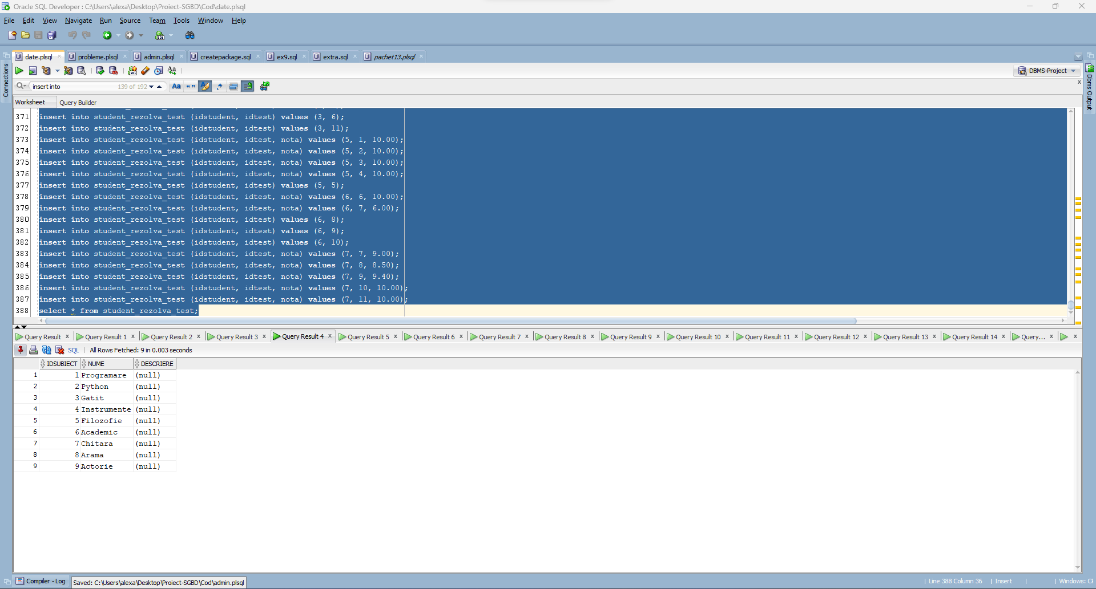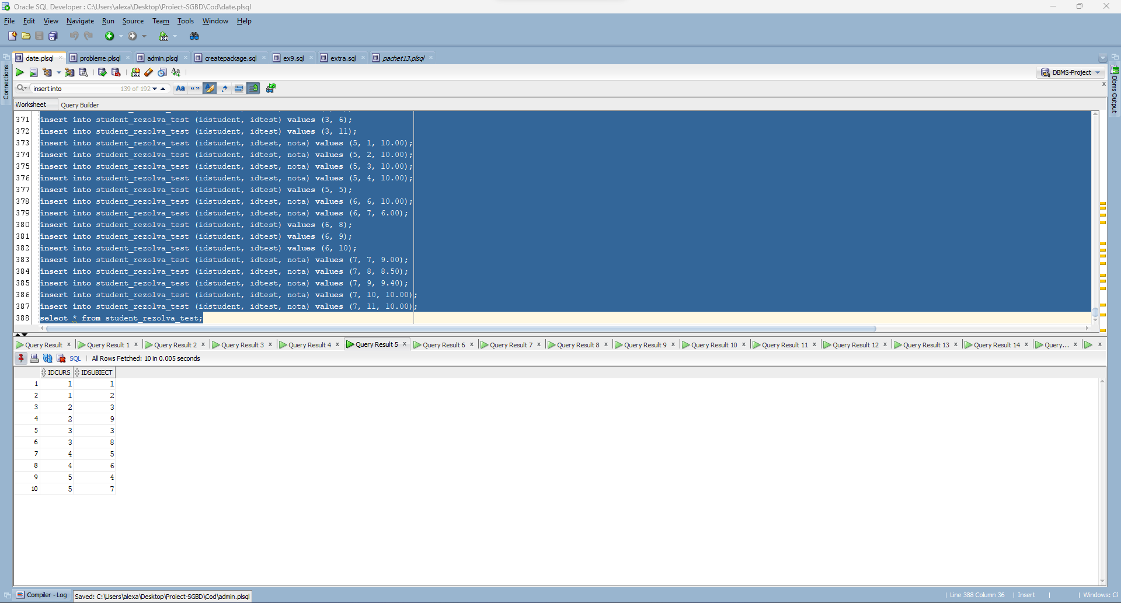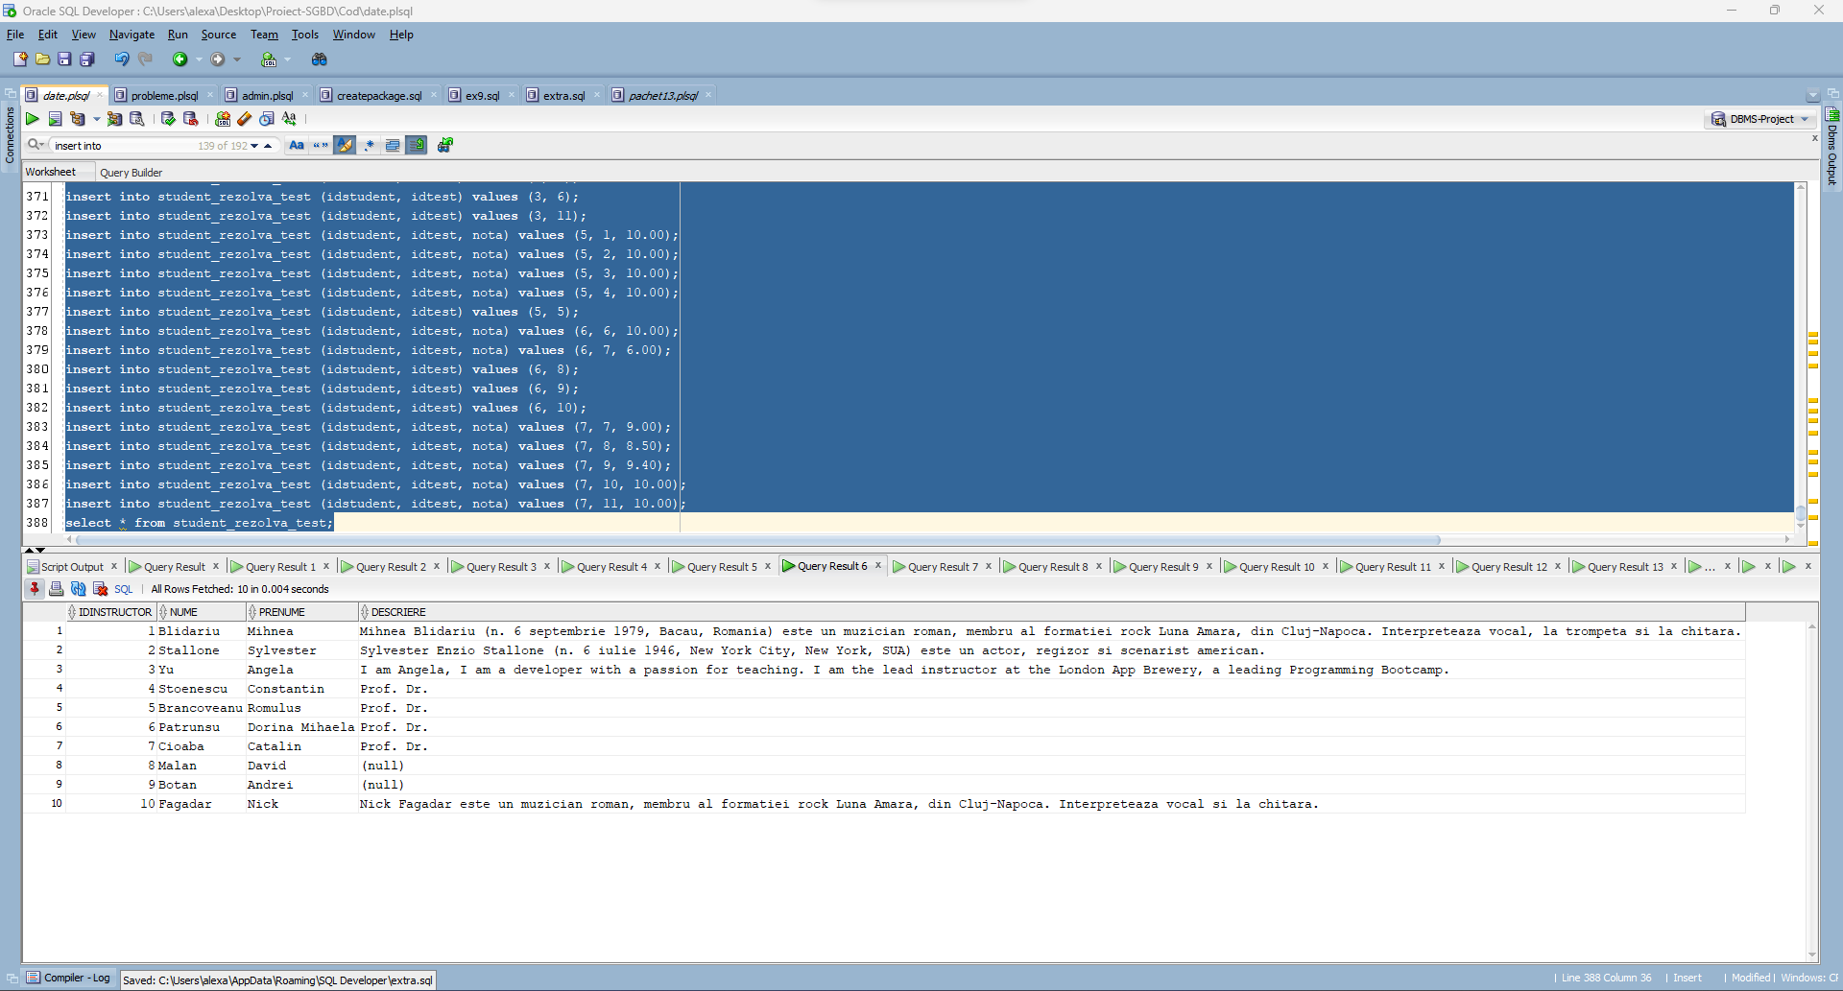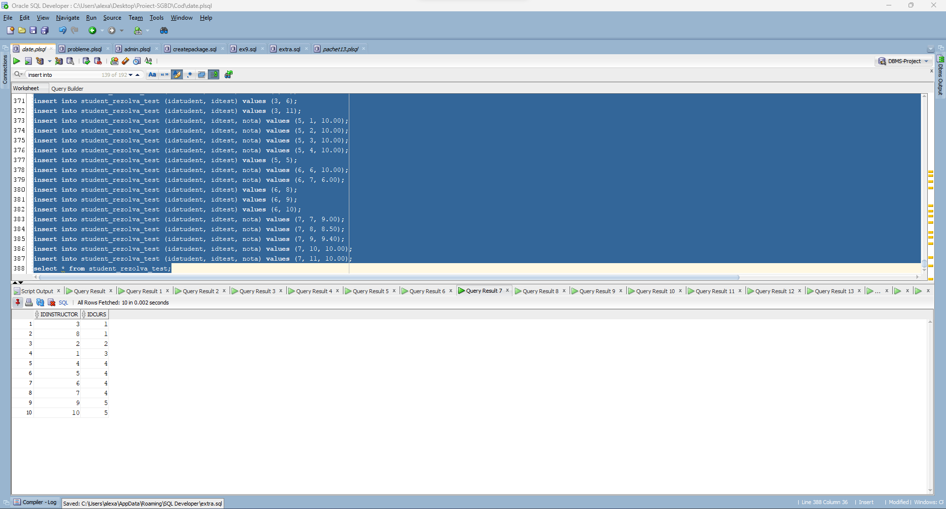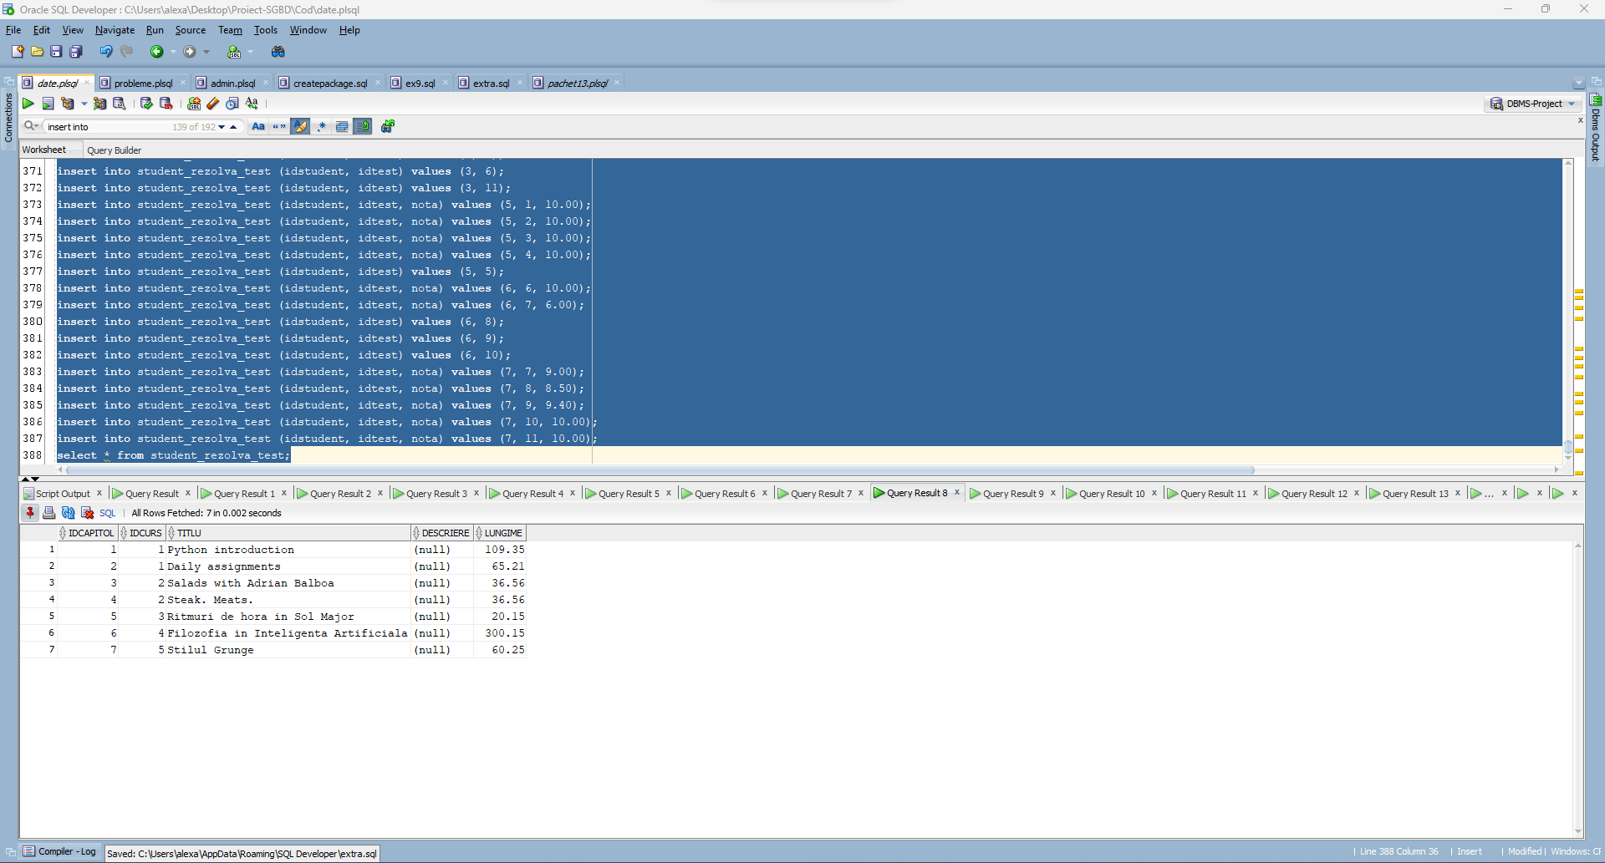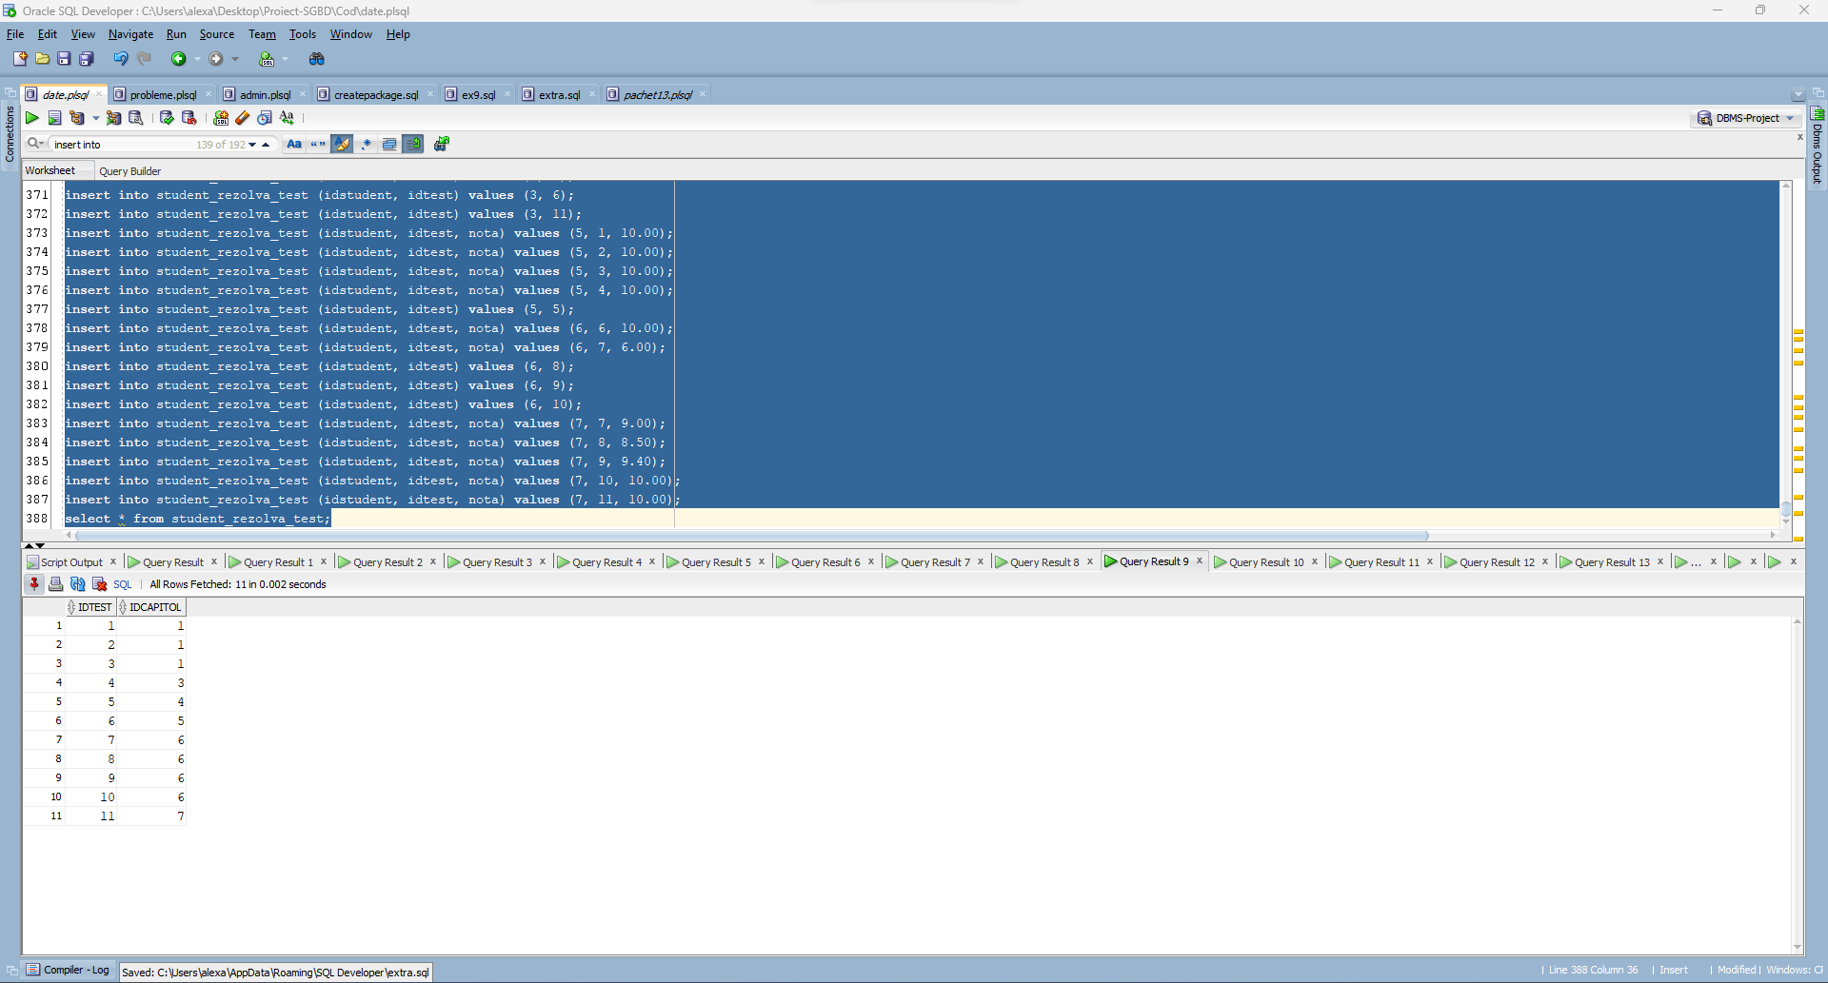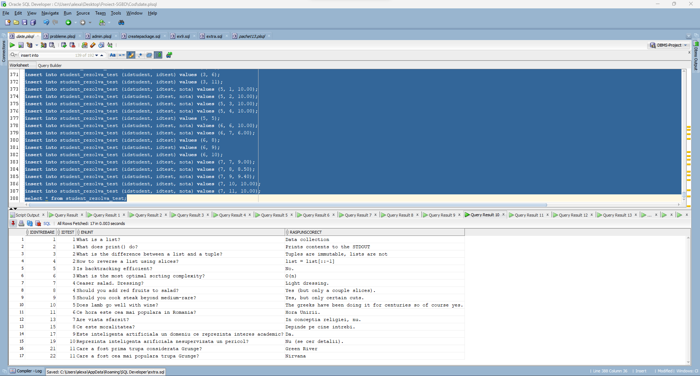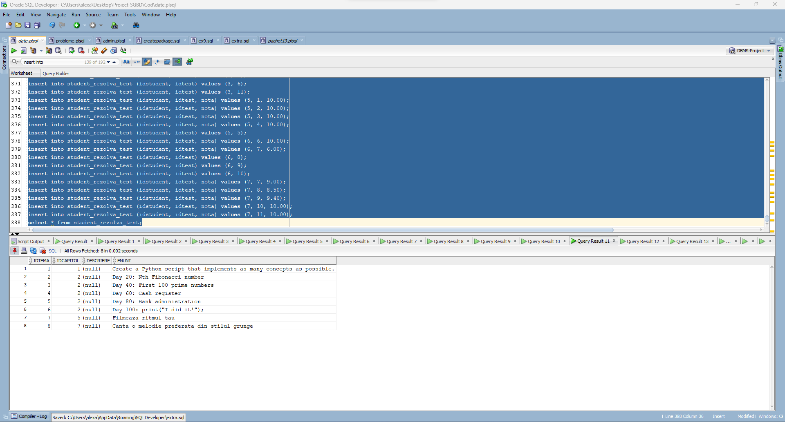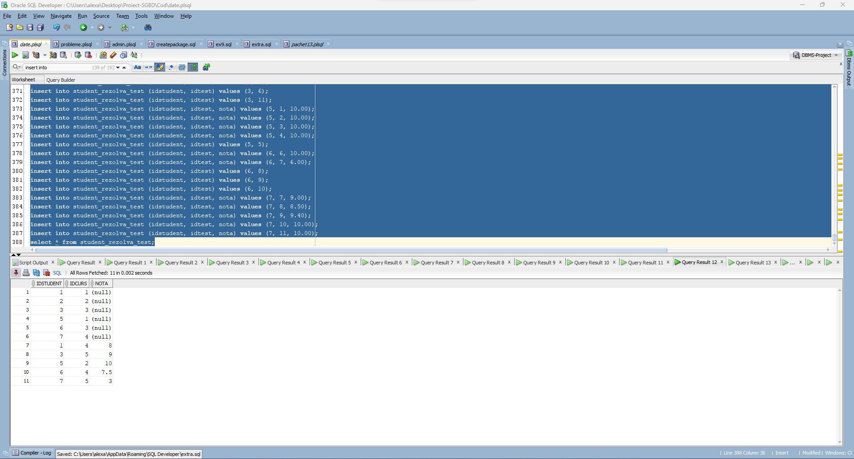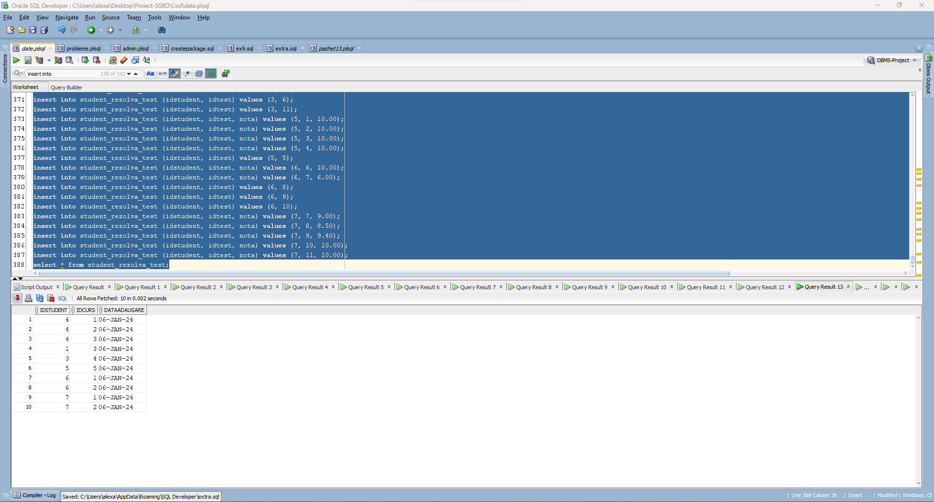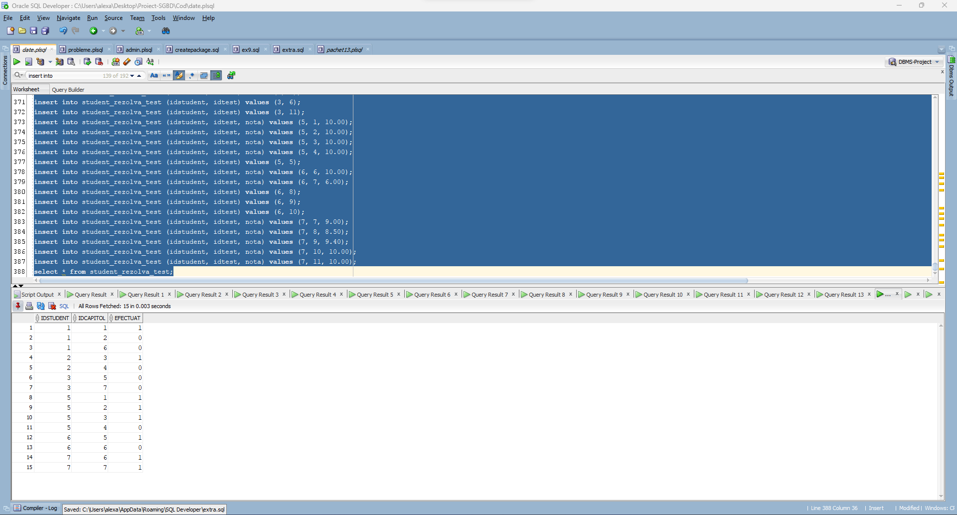

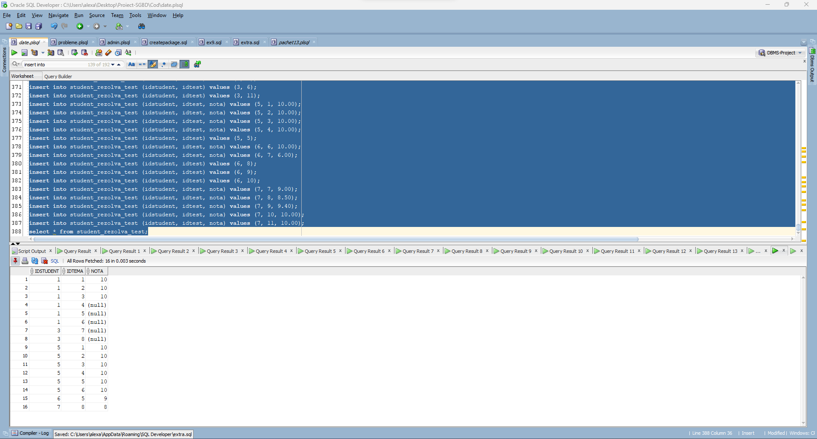

**6. Formulați în limbaj natural o problemă pe care să o rezolvați folosind un subprogram stocat independent care să utilizeze toate cele 3 tipuri de colecții studiate. Apelați subprogramul.**

**Pentru un student al carui ID se da de la tastatura sa se afiseze cursurile pe care le-a cumparat pentru fiecare curs cumparat sa se enumere intrebarile din testele aferente fiecarui capitol al cursului, cat si raspunsurile corecte.**

CREATE OR REPLACE PROCEDURE afisare_sarcini_de_lucru (v_id student.idstudent%type) as

TYPE date_curs IS RECORD (id curs.idcurs%type, nume curs.nume%type);

TYPE date_intrebare IS RECORD (enunt intrebare.enunt%type, raspuns intrebare.raspunscorect%type);

TYPE date_capitol IS RECORD (id capitol.idcapitol%type, titlu capitol.titlu%type);

TYPE t_curs IS TABLE OF date_curs INDEX BY PLS_INTEGER;

TYPE t_capitol IS TABLE OF date_capitol;

TYPE t_intrebare IS TABLE OF date_intrebare;

TYPE t_test IS VARRAY(100) of test.IDTEST%type;

nume_curs t_curs;

titluri_capitol t_capitol := t_capitol();

intrebari t_intrebare := t_intrebare();

teste t_test := t_test();

v_idcurs curs.IDCURS%type;

nume_s student.nume%type;

datacreare_s student.datacreare%type;

BEGIN

-- cursurile detinute de studentul dat ca parametru

select nume || ' ' || prenume, datacreare into nume_s, datacreare_s from student where idstudent = v_id;

DBMS_OUTPUT.PUT_LINE('Studentul ' || nume_s || ', care s-a intregistrat la data de ' || datacreare_s || ' a cumparat urmatoarele cursuri: ');

select cu.idcurs, cu.nume bulk COLLECT INTO nume_curs

from card ca, CARD_CUMPARA_CURS ccc, curs cu

where v_id = ca.IDSTUDENT and ccc.IDCARD = ca.IDCARD and cu.IDCURS = ccc.IDCURS;

for i in nume_curs.first..nume_curs.last LOOP

DBMS_OUTPUT.PUT_LINE('Cursul ' || nume_curs(i).nume || ' are urmatoarele capitole: ');

v_idcurs := nume_curs(i).id;

select idcapitol, titlu bulk collect into titluri_capitol

from capitol

where idcurs = v_idcurs;

for j in titluri_capitol.first..titluri_capitol.last loop

DBMS_OUTPUT.PUT(' ' || titluri_capitol(j).titlu || ', care ');

-- ia testele aferente capitolului

select idtest bulk collect into teste

from TEST

where IDCAPITOL = titluri_capitol(j).id;

if teste.count != 0 then

dbms_output.PUT_LINE('are ' || teste.count || ' teste:');

for k in teste.first..teste.last LOOP

-- ia intrebarile din test

dbms_output.put_line(' Testul ' || k || ':');

select enunt, raspunscorect bulk collect into intrebari

from INTREBARE

where idtest = teste(k);

for l in intrebari.first..intrebari.last LOOP

-- TODO see how to correct output

DBMS_OUTPUT.PUT_line(' Intrebarea ' || l || ': ' || intrebari(l).enunt);

DBMS_OUTPUT.PUT_LINE(' Raspunsul corect este: ' || intrebari(l).raspuns);

end loop;

end loop;

ELSE

DBMS_OUTPUT.PUT_LINE('nu are teste.');

end if;

end loop;

end loop;

END afisare_sarcini_de_lucru;

/

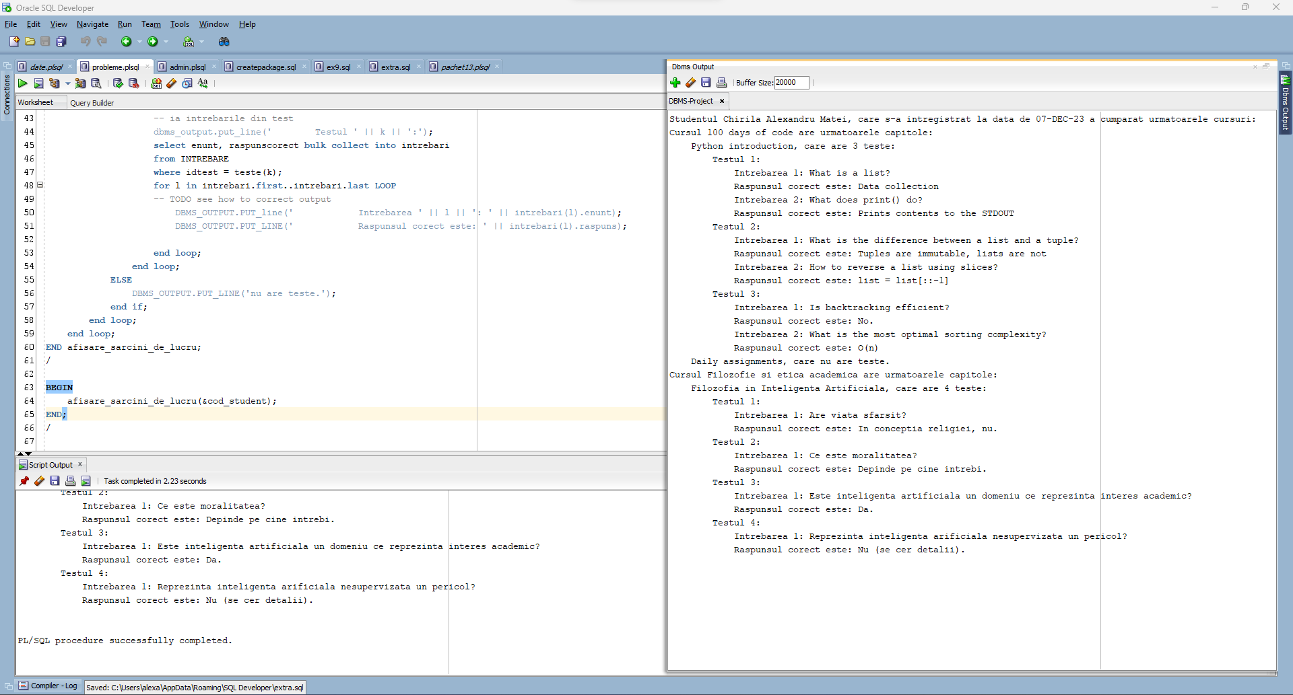

**7. Formulați în limbaj natural o problemă pe care să o rezolvați folosind un subprogram stocat independent care să utilizeze 2 tipuri diferite de cursoare studiate, unul dintre acestea fiind cursor parametrizat, dependent de celălalt cursor. Apelați subprogramul.**

**Pentru fiecare student, sa se afiseze cardurile pe care si le-a inregistrat, si ce cursuri a cumparat cu fiecare.**

CREATE OR REPLACE PROCEDURE afisare_cumparaturi as

id_s student.idstudent%type;

nume_s student.nume%type;

nume_c curs.nume%type;

pret_c curs.pret%type;

-- cursor explicit

cursor studenti is

select idstudent, nume || ' ' || prenume

from student;

cursor cursuri (id_c card.idcard%type) IS

select idcurs from CARD_CUMPARA_CURS where idcard = id_c;

BEGIN

open studenti;

loop

fetch studenti into id_s, nume_s;

exit when studenti%notfound;

dbms_output.put_line('Studentul ' || nume_s || ' are inregistrate urmatoarele carduri:');

-- cursor implicit

for i in (select idcard, detinator, numar from card where idstudent = id_s) LOOP

DBMS_OUTPUT.PUT_LINE(' ' || i.detinator || ', cu codul ' || i.numar || ', de pe care a cumparat urmatoarele cursuri:');

for j in cursuri(i.idcard) LOOP

select nume, pret into nume_c, pret_c

from curs where idcurs = j.idcurs;

DBMS_OUTput.PUT_LINE(' ' || nume_c || ', care costa ' || pret_c || ' lei.');

end loop;

end loop;

end loop;

END afisare_cumparaturi;

/

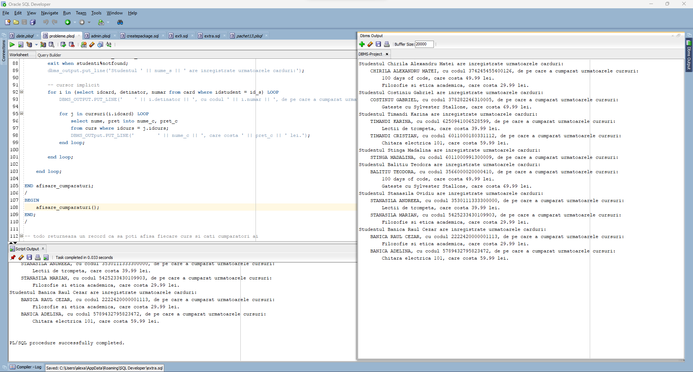

**8. Formulați în limbaj natural o problemă pe care să o rezolvați folosind un subprogram stocat independent de tip funcție care să utilizeze într-o singură comandă SQL 3 dintre tabelele definite. Definiți minim 2 excepții proprii. Apelați subprogramul astfel încât să evidențiați toate cazurile definite și tratate.**

**Pentru un instructor al carui nume se da la tastatura sa se afiseze cate copii ale tuturor cursurilor pe care le preda au fost cumparate, pentru fiecare curs.**

CREATE OR REPLACE FUNCTION numar_clienti (nume_instr instructor.nume%type) RETURN number AS

ret_nrvanzari number;

v_nrinst int;

v_idinst int;

nu_exista_instructor EXCEPTION;

PRAGMA EXCEPTION_INIT (nu_exista_instructor, -20000);

mai_multi_instructori EXCEPTION;

PRAGMA EXCEPTION_INIT (mai_multi_instructori, -20001);

BEGIN

select count(*) into v_nrinst from instructor where nume = nume_instr;

if v_nrinst > 1 then

raise_application_error(-20000, 'Sunt mai multi instructori cu numele dat!');

elsif v_nrinst < 1 then

raise_application_error(-20001, 'Nu exista instructori cu numele dat!');

end if;

dbms_output.put_line('Despre instructorul ' || nume_instr || ' stim urmatoarele: ');

for linie in (select c.nume, count(ccc.idcard) cumparari

from instructor i, instructor_preda_curs ipc, card_cumpara_curs ccc, curs c

where i.nume = nume_instr and i.idinstructor = ipc.idinstructor and ipc.idcurs = ccc.idcurs and ipc.idcurs = c.idcurs

group by c.nume) loop

ret_nrvanzari := ret_nrvanzari + linie.cumparari;

dbms_output.put_line(' Cursul ' || linie.nume || ' are ' || linie.cumparari || ' vanzari.');

end loop;

return ret_nrvanzari;

END numar_clienti;

/

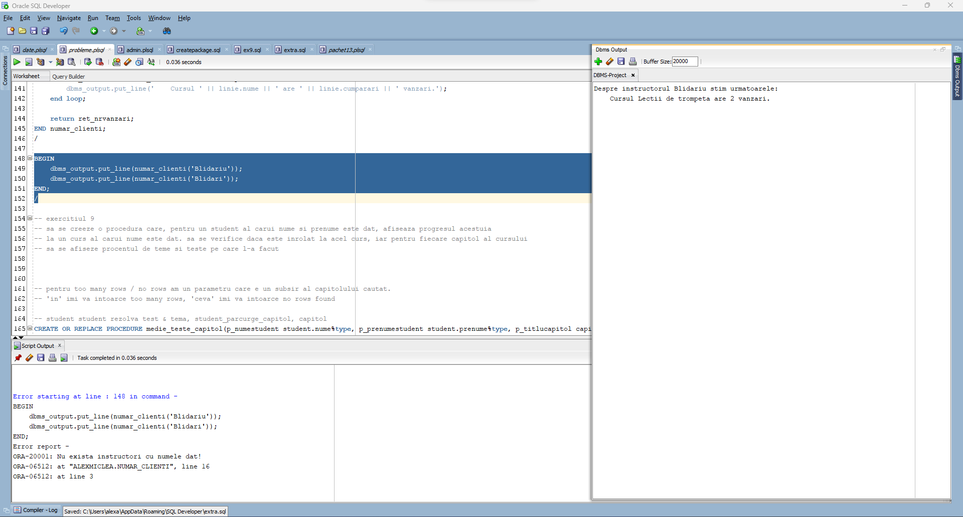

**9. Formulați în limbaj natural o problemă pe care să o rezolvați folosind un subprogram stocat independent de tip procedură care să utilizeze într-o singură comandă SQL 5 dintre tabelele definite. Tratați toate excepțiile care pot apărea, incluzând excepțiile NO_DATA_FOUND și TOO_MANY_ROWS. Apelați subprogramul astfel încât să evidențiați toate cazurile tratate.**

**Sa se creeze o procedura care, pentru un student al carui nume si prenume este dat, afiseaza progresul acestuia la un curs al carui nume este dat. sa se verifice daca este inrolat la acel curs, iar pentru fiecare capitol al cursului sa se afiseze procentul de teme si teste pe care l-a facut.**

CREATE OR REPLACE PROCEDURE medie_teste_capitol(p_numestudent student.nume%type, p_prenumestudent student.prenume%type, p_titlucapitol capitol.titlu%type) AS

v_aux number;

v_numestudent student.nume%type;

v_prenumestudent student.prenume%type;

v_titlucapitol capitol.titlu%type;

v_medienote number(4,2);

BEGIN

select s.nume, s.prenume, c.titlu, avg(nvl(srtest.nota,0)) medie into v_numestudent, v_prenumestudent, v_titlucapitol, v_medienote

from student s, capitol c, student_parcurge_capitol spc, student_rezolva_test srtest, test

where lower(s.nume) = lower(p_numestudent) and lower(s.prenume) = lower(p_prenumestudent) and spc.idstudent = s.idstudent and spc.idcapitol = c.idcapitol

and srtest.idstudent = s.idstudent

and test.idtest = srtest.idtest

and test.idcapitol = c.idcapitol

and instr(lower(c.titlu), lower(p_titlucapitol), 1) > 0

group by s.nume, s.prenume, c.titlu;

dbms_output.put_line('Studentul ' || v_numestudent || ' ' || v_prenumestudent || ' are media ' || v_medienote || ' la testele din capitolul ' || v_titlucapitol);

EXCEPTION

when no_data_found then

select count(*) into v_aux

from student

where lower(student.nume) = lower(p_numestudent) and lower(student.prenume) = lower(p_prenumestudent);

if v_aux = 0 then

dbms_output.put_line('Studentul cu numele si prenumele dat nu exista!');

end if;

select count(distinct c.titlu) into v_aux

from student s, capitol c, student_parcurge_capitol spc, test

where spc.idstudent = s.idstudent and spc.idcapitol = c.idcapitol

and instr(lower(c.titlu), lower(p_titlucapitol), 1) > 0

and spc.efectuat = 1

and test.idcapitol = c.idcapitol

and lower(s.nume) = lower(p_numestudent) and lower(s.prenume) = lower(p_prenumestudent);

if v_aux = 0 then

dbms_output.put_line('Nu s-a putut gasi un capitol cu subsirul dat!');

end if;

when too_many_rows then

select count(*) into v_aux

from student

where lower(student.nume) = lower(p_numestudent) and lower(student.prenume) = lower(p_prenumestudent);

if v_aux > 1 then

dbms_output.put_line('Exista mai multi studenti cu numele si prenumele dat!');

end if;

select count(distinct c.titlu) into v_aux

from student s, capitol c, student_parcurge_capitol spc, test

where spc.idstudent = s.idstudent and spc.idcapitol = c.idcapitol

and instr(lower(c.titlu), lower(p_titlucapitol), 1) > 0

and spc.efectuat = 1

and test.idcapitol = c.idcapitol

and lower(s.nume) = lower(p_numestudent) and lower(s.prenume) = lower(p_prenumestudent);

if v_aux > 1 then

dbms_output.put_line('Exista mai multe capitole care au in componenta subsirul dat (fiti mai explicit)!');

end if;

END medie_teste_capitol;

/

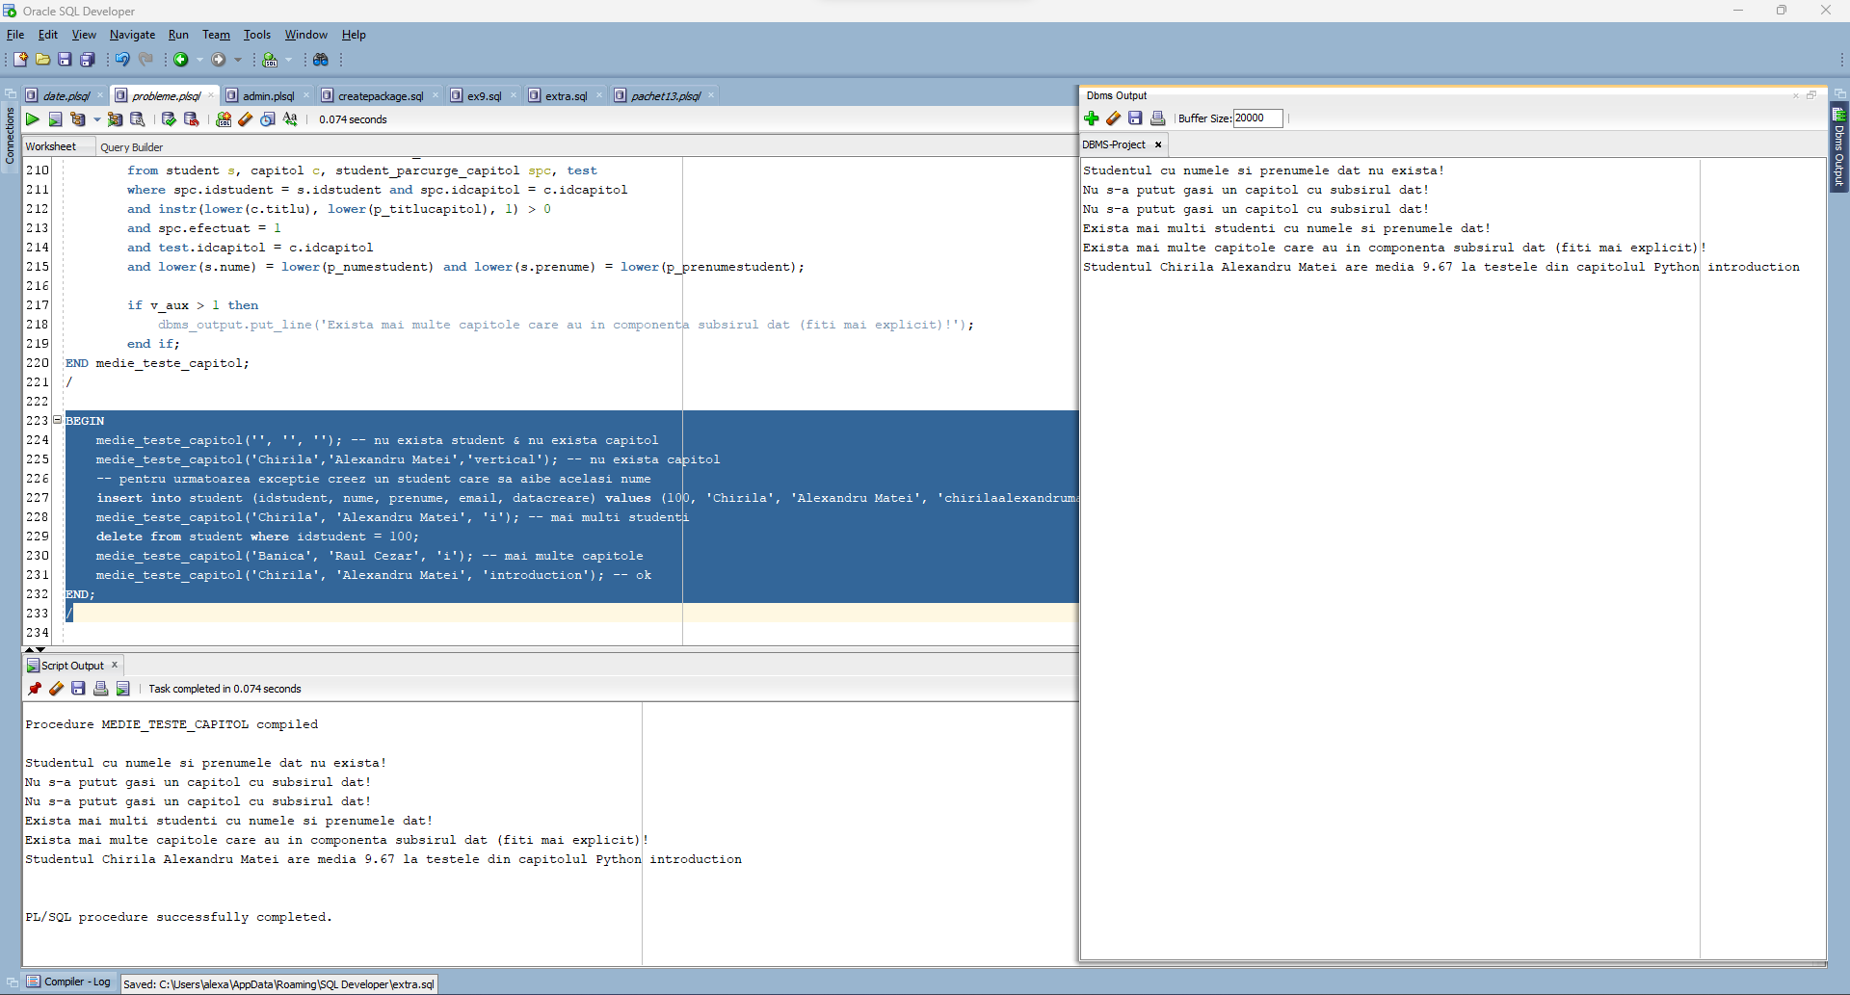

**10. Definiți un trigger de tip LMD la nivel de comandă. Declanșați trigger-ul.**

**Implementati un trigger prin care doar administratorul bazei de date poate modifica, insera sau sterge un curs din baza de date.**

create or replace trigger t_admincurs

before insert or update or delete on curs

declare

begin

if (lower(sys.login_user) != 'sys') then

raise_application_error(-20900, 'Doar administratorul bazei de date poate efectua modificari pe tabela de cursuri!');

end if;

end;

/

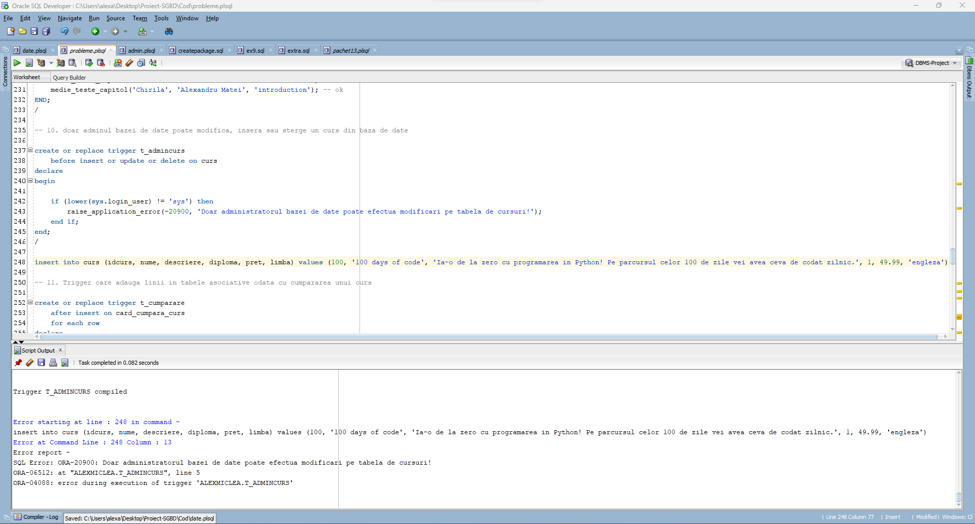

**11. Definiți un trigger de tip LMD la nivel de linie. Declanșați trigger-ul.**

**Implementati un trigger care adauga in baza de date linii de interes in tabelele asociative (ex: student rezolva tema) atunci cand un curs este cumparat cu un card.**

create or replace trigger t_cumparare

after insert on card_cumpara_curs

for each row

declare

v_numarlinii int;

v_idstudent int;

v_idcapitol int;

type v_iduri is varray(10) of int;

v_idcapitole v_iduri;

v_idteste v_iduri;

v_idteme v_iduri;

begin

if inserting then

select c.idstudent into v_idstudent

from card c

where c.idcard = :NEW.idcard;

select idcapitol bulk collect into v_idcapitole

from capitol

where idcurs = :NEW.idcurs;

for i in v_idcapitole.first..v_idcapitole.last loop

insert into student_parcurge_capitol (idstudent, idcapitol, efectuat) values (v_idstudent, i, 0);

select count(*) into v_numarlinii

from test where idcapitol = i;

if (v_numarlinii > 0) then

select idtest bulk collect into v_idteste

from test

where idcapitol = i;

end if;

select count(*) into v_numarlinii

from tema where idcapitol = i;

if (v_numarlinii > 0) then

select idtema bulk collect into v_idteme

from tema

where idcapitol = i;

end if;

end loop;

insert into student_noteaza_curs (idstudent, idcurs) values (v_idstudent, :NEW.idcurs);

for i in v_idteste.first..v_idteste.last loop

insert into student_rezolva_test (idstudent, idtest) values (v_idstudent, i);

end loop;

for i in v_idteme.first..v_idteme.last loop

insert into student_rezolva_tema (idstudent, idtema) values (v_idstudent, i);

end loop;

end if;

end;

/

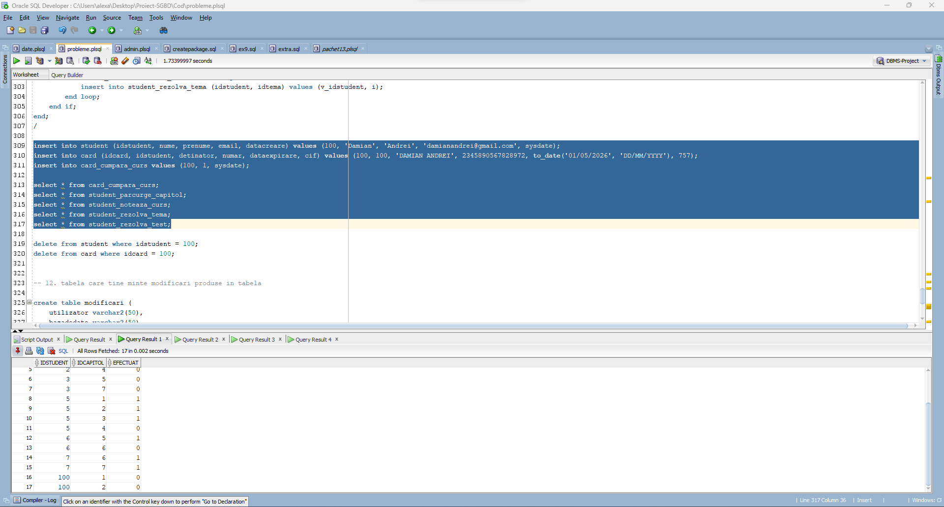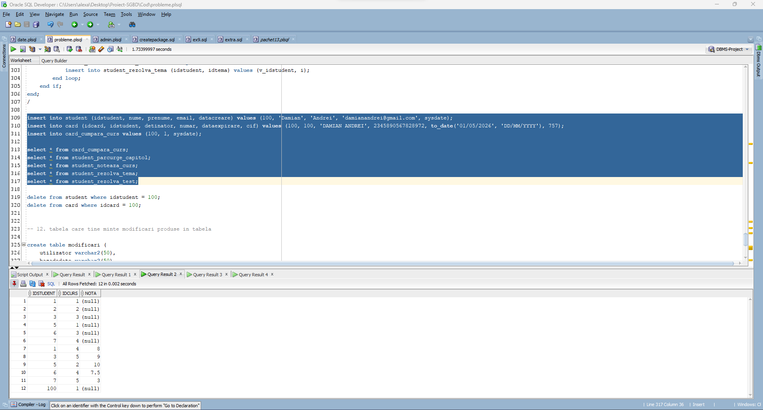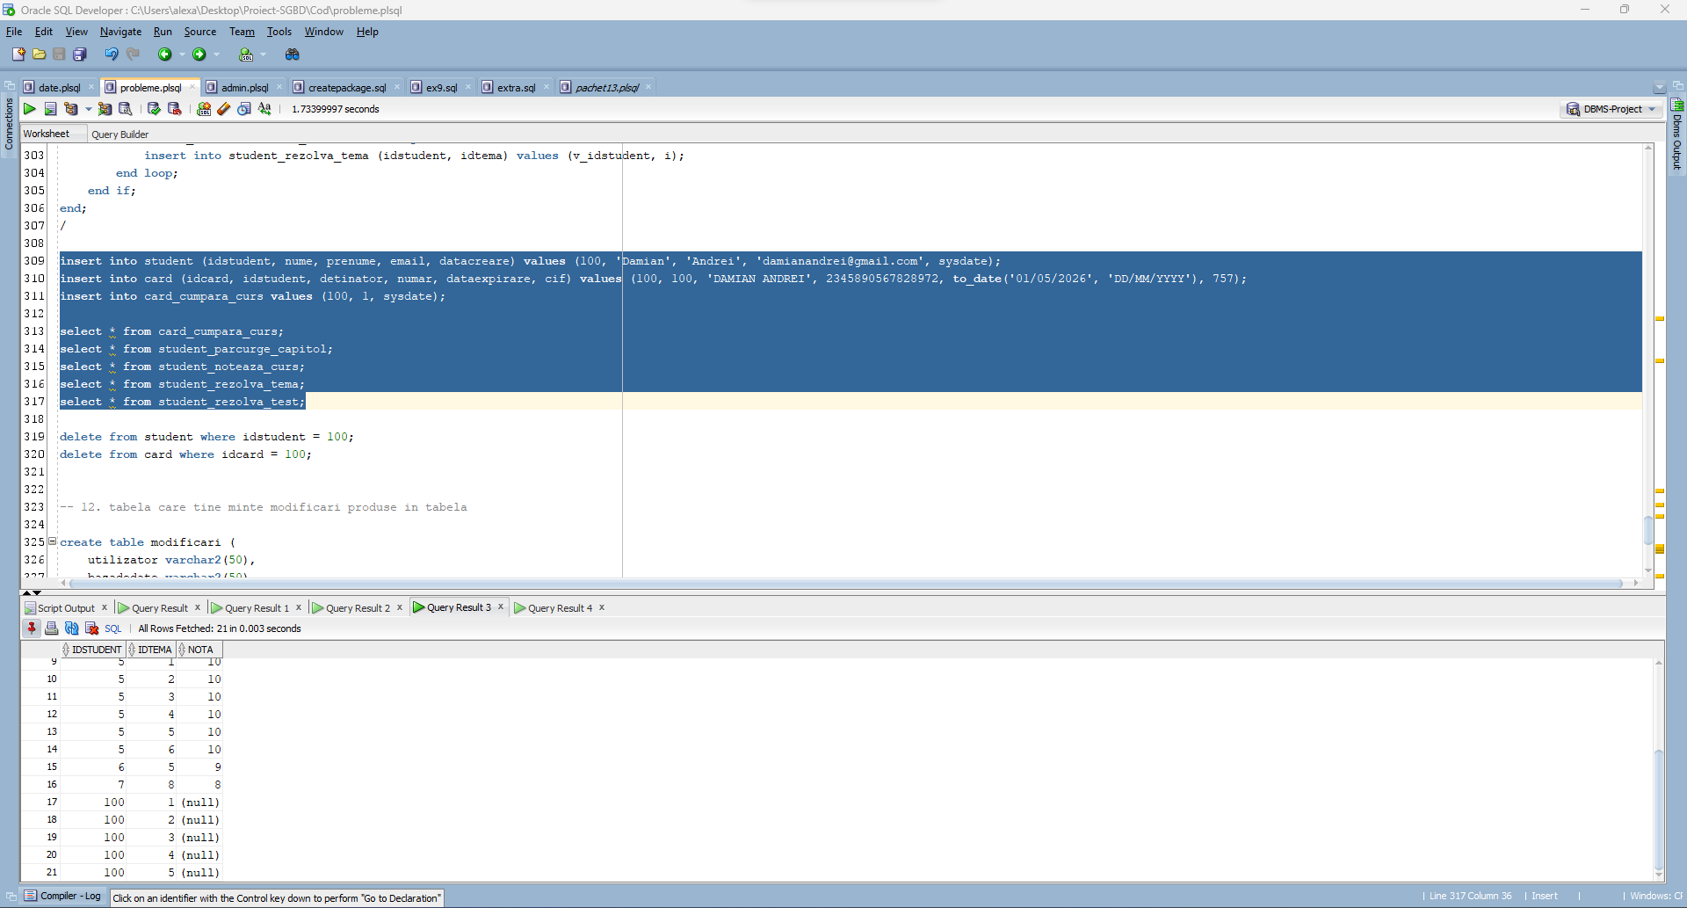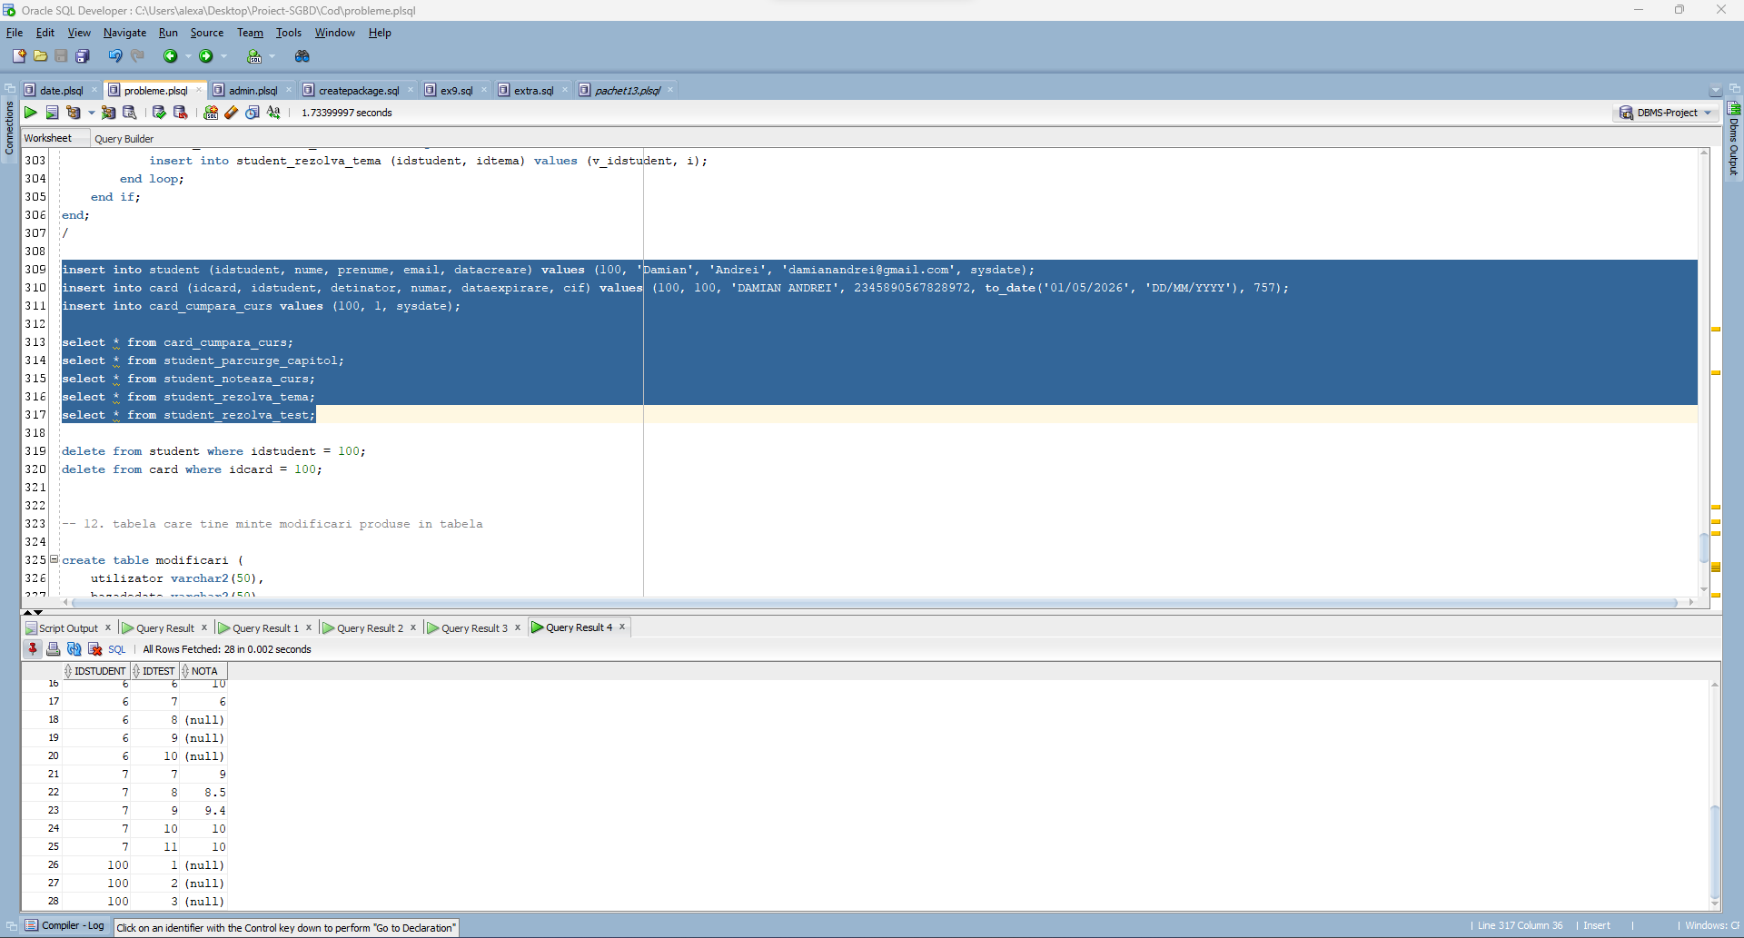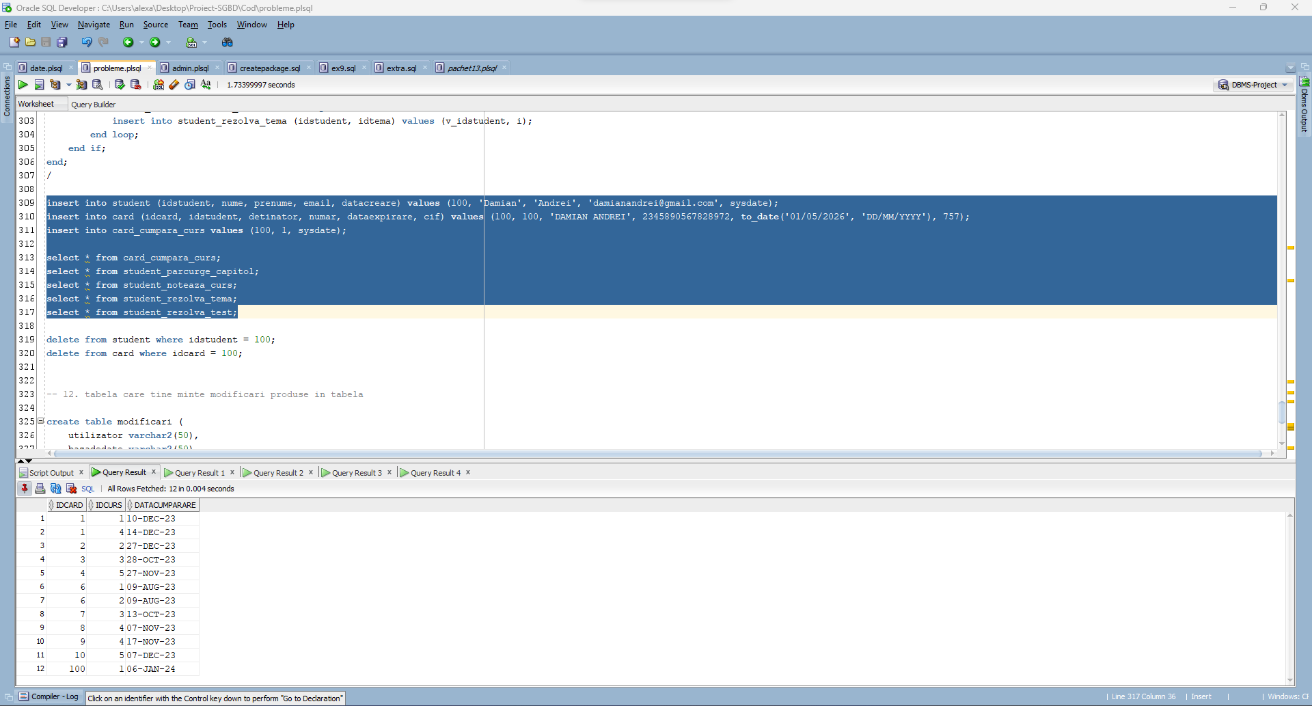

**12. Definiți un trigger de tip LDD. Declanșați trigger-ul.**

**Definiti o tabela in care sa se tina cont de datele despre o modificare adusa bazei de date. Implementati un trigger care sa introduca date in aceasta tabela.**

create table modificari (

utilizator varchar2(50),

bazadedate varchar2(50),

modificare varchar2(50),

numeobiect varchar2(50),

dataefectuare date default sysdate

);

select * from modificari;

create or replace trigger t_modificari

after alter or create or drop on schema

begin

insert into modificari (utilizator, bazadedate, modificare, numeobiect)

values (sys.login_user, sys.database_name, sys.sysevent, sys.dictionary_obj_name);

end;

/

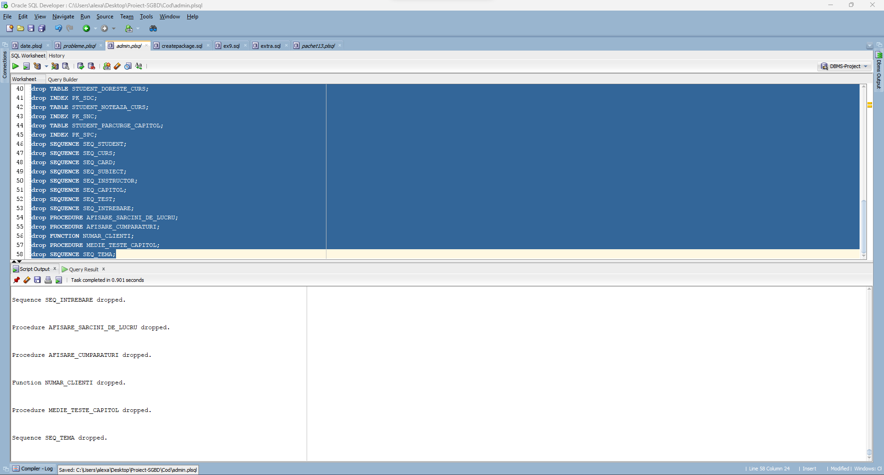

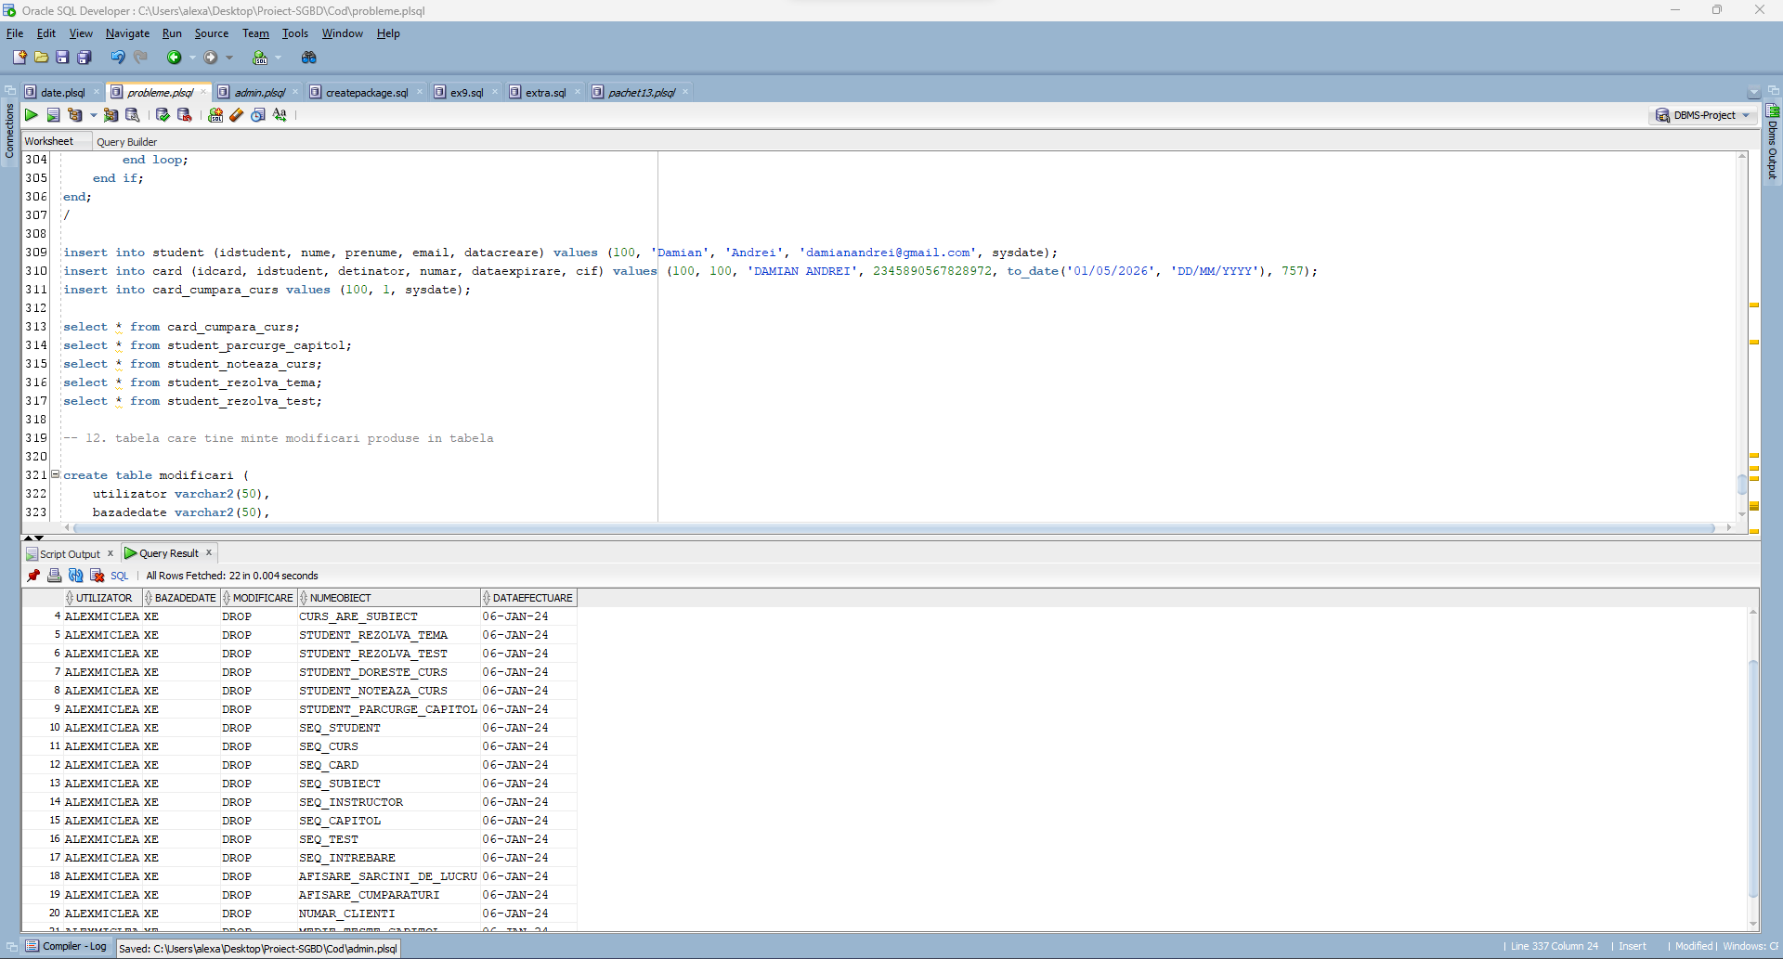

**13. Definiți un pachet care să conțină toate obiectele definite în cadrul proiectului.**

create or replace package tema_sgbd as

PROCEDURE afisare_sarcini_de_lucru (v_id student.idstudent%type);

PROCEDURE afisare_cumparaturi;

FUNCTION numar_clienti (nume_instr instructor.nume%type) RETURN number;

PROCEDURE medie_teste_capitol(p_numestudent student.nume%type, p_prenumestudent student.prenume%type, p_titlucapitol capitol.titlu%type);

end tema_sgbd;

create or replace package body tema_sgbd as

PROCEDURE afisare_sarcini_de_lucru (v_id student.idstudent%type) as

TYPE date_curs IS RECORD (id curs.idcurs%type, nume curs.nume%type);

TYPE date_intrebare IS RECORD (enunt intrebare.enunt%type, raspuns intrebare.raspunscorect%type);

TYPE date_capitol IS RECORD (id capitol.idcapitol%type, titlu capitol.titlu%type);

TYPE t_curs IS TABLE OF date_curs INDEX BY PLS_INTEGER;

TYPE t_capitol IS TABLE OF date_capitol;

TYPE t_intrebare IS TABLE OF date_intrebare;

TYPE t_test IS VARRAY(100) of test.IDTEST%type;

nume_curs t_curs;

titluri_capitol t_capitol := t_capitol();

intrebari t_intrebare := t_intrebare();

teste t_test := t_test();

v_idcurs curs.IDCURS%type;

nume_s student.nume%type;

datacreare_s student.datacreare%type;

BEGIN

-- cursurile detinute de studentul dat ca parametru

select nume || ' ' || prenume, datacreare into nume_s, datacreare_s from student where idstudent = v_id;

DBMS_OUTPUT.PUT_LINE('Studentul ' || nume_s || ', care s-a intregistrat la data de ' || datacreare_s || ' a cumparat urmatoarele cursuri: ');

select cu.idcurs, cu.nume bulk COLLECT INTO nume_curs

from card ca, CARD_CUMPARA_CURS ccc, curs cu

where v_id = ca.IDSTUDENT and ccc.IDCARD = ca.IDCARD and cu.IDCURS = ccc.IDCURS;

for i in nume_curs.first..nume_curs.last LOOP

DBMS_OUTPUT.PUT_LINE('Cursul ' || nume_curs(i).nume || ' are urmatoarele capitole: ');

v_idcurs := nume_curs(i).id;

select idcapitol, titlu bulk collect into titluri_capitol

from capitol

where idcurs = v_idcurs;

for j in titluri_capitol.first..titluri_capitol.last loop

DBMS_OUTPUT.PUT(' ' || titluri_capitol(j).titlu || ', care ');

-- ia testele aferente capitolului

select idtest bulk collect into teste

from TEST

where IDCAPITOL = titluri_capitol(j).id;

if teste.count != 0 then

dbms_output.PUT_LINE('are ' || teste.count || ' teste:');

for k in teste.first..teste.last LOOP

-- ia intrebarile din test

dbms_output.put_line(' Testul ' || k || ':');

select enunt, raspunscorect bulk collect into intrebari

from INTREBARE

where idtest = teste(k);

for l in intrebari.first..intrebari.last LOOP

-- TODO see how to correct output

DBMS_OUTPUT.PUT_line(' Intrebarea ' || l || ': ' || intrebari(l).enunt);

DBMS_OUTPUT.PUT_LINE(' Raspunsul corect este: ' || intrebari(l).raspuns);

end loop;

end loop;

ELSE

DBMS_OUTPUT.PUT_LINE('nu are teste.');

end if;

end loop;

end loop;

END afisare_sarcini_de_lucru;

PROCEDURE afisare_cumparaturi as

id_s student.idstudent%type;

nume_s student.nume%type;

nume_c curs.nume%type;

pret_c curs.pret%type;

-- cursor explicit

cursor studenti is

select idstudent, nume || ' ' || prenume

from student;

cursor cursuri (id_c card.idcard%type) IS

select idcurs from CARD_CUMPARA_CURS where idcard = id_c;

BEGIN

open studenti;

loop

fetch studenti into id_s, nume_s;

exit when studenti%notfound;

dbms_output.put_line('Studentul ' || nume_s || ' are inregistrate urmatoarele carduri:');

-- cursor implicit

for i in (select idcard, detinator, numar from card where idstudent = id_s) LOOP

DBMS_OUTPUT.PUT_LINE(' ' || i.detinator || ', cu codul ' || i.numar || ', de pe care a cumparat urmatoarele cursuri:');

for j in cursuri(i.idcard) LOOP

select nume, pret into nume_c, pret_c

from curs where idcurs = j.idcurs;

DBMS_OUTput.PUT_LINE(' ' || nume_c || ', care costa ' || pret_c || ' lei.');

end loop;

end loop;

end loop;

END afisare_cumparaturi;

FUNCTION numar_clienti (nume_instr instructor.nume%type) RETURN number AS

ret_nrvanzari number;

v_nrinst int;

v_idinst int;

nu_exista_instructor EXCEPTION;

PRAGMA EXCEPTION_INIT (nu_exista_instructor, -20000);

mai_multi_instructori EXCEPTION;

PRAGMA EXCEPTION_INIT (mai_multi_instructori, -20001);

BEGIN

select count(*) into v_nrinst from instructor where nume = nume_instr;

if v_nrinst > 1 then

raise_application_error(-20000, 'Sunt mai multi instructori cu numele dat!');

elsif v_nrinst < 1 then

raise_application_error(-20001, 'Nu exista instructori cu numele dat!');

end if;

dbms_output.put_line('Despre instructorul ' || nume_instr || ' stim urmatoarele: ');

for linie in (select c.nume, count(ccc.idcard) cumparari

from instructor i, instructor_preda_curs ipc, card_cumpara_curs ccc, curs c

where i.nume = nume_instr and i.idinstructor = ipc.idinstructor and ipc.idcurs = ccc.idcurs and ipc.idcurs = c.idcurs

group by c.nume) loop

ret_nrvanzari := ret_nrvanzari + linie.cumparari;

dbms_output.put_line(' Cursul ' || linie.nume || ' are ' || linie.cumparari || ' vanzari.');

end loop;

return ret_nrvanzari;

END numar_clienti;

PROCEDURE medie_teste_capitol(p_numestudent student.nume%type, p_prenumestudent student.prenume%type, p_titlucapitol capitol.titlu%type) AS

v_aux number;

v_numestudent student.nume%type;

v_prenumestudent student.prenume%type;

v_titlucapitol capitol.titlu%type;

v_medienote number(4,2);

BEGIN

select s.nume, s.prenume, c.titlu, avg(nvl(srtest.nota,0)) medie into v_numestudent, v_prenumestudent, v_titlucapitol, v_medienote

from student s, capitol c, student_parcurge_capitol spc, student_rezolva_test srtest, test

where lower(s.nume) = lower(p_numestudent) and lower(s.prenume) = lower(p_prenumestudent) and spc.idstudent = s.idstudent and spc.idcapitol = c.idcapitol

and srtest.idstudent = s.idstudent

and test.idtest = srtest.idtest

and test.idcapitol = c.idcapitol

and instr(lower(c.titlu), lower(p_titlucapitol), 1) > 0

group by s.nume, s.prenume, c.titlu;

dbms_output.put_line('Studentul ' || v_numestudent || ' ' || v_prenumestudent || ' are media ' || v_medienote || ' la testele din capitolul ' || v_titlucapitol);

EXCEPTION

when no_data_found then

select count(*) into v_aux

from student

where lower(student.nume) = lower(p_numestudent) and lower(student.prenume) = lower(p_prenumestudent);

if v_aux = 0 then

dbms_output.put_line('Studentul cu numele si prenumele dat nu exista!');

end if;

select count(distinct c.titlu) into v_aux

from student s, capitol c, student_parcurge_capitol spc, test

where spc.idstudent = s.idstudent and spc.idcapitol = c.idcapitol

and instr(lower(c.titlu), lower(p_titlucapitol), 1) > 0

and spc.efectuat = 1

and test.idcapitol = c.idcapitol

and lower(s.nume) = lower(p_numestudent) and lower(s.prenume) = lower(p_prenumestudent);

if v_aux = 0 then

dbms_output.put_line('Nu s-a putut gasi un capitol cu subsirul dat!');

end if;

when too_many_rows then

select count(*) into v_aux

from student

where lower(student.nume) = lower(p_numestudent) and lower(student.prenume) = lower(p_prenumestudent);

if v_aux > 1 then

dbms_output.put_line('Exista mai multi studenti cu numele si prenumele dat!');

end if;

select count(distinct c.titlu) into v_aux

from student s, capitol c, student_parcurge_capitol spc, test

where spc.idstudent = s.idstudent and spc.idcapitol = c.idcapitol

and instr(lower(c.titlu), lower(p_titlucapitol), 1) > 0

and spc.efectuat = 1

and test.idcapitol = c.idcapitol

and lower(s.nume) = lower(p_numestudent) and lower(s.prenume) = lower(p_prenumestudent);

if v_aux > 1 then

dbms_output.put_line('Exista mai multe capitole care au in componenta subsirul dat (fiti mai explicit)!');

end if;

END medie_teste_capitol;

END tema_sgbd;

/

